Abstract

Navigating the campus of a particularly large institution, can be a difficult task for those not familiar with the area. Other factors, such as mobility impairment, can make the task even more difficult for certain visitors. In order to combat this problem, a mobile application was developed which provides the user with a route between any two rooms or buildings within a campus.

The mobile application depends on a large amount of data, which could not be obtained for a whole campus within the duration of the project. In order to show the abilities of the application, the data for several floors in different buildings within the John Anderson campus at the University of Strathclyde was collected. The application works as expected with the subset of data collected. A study was performed into the expected level of responsiveness from the application, once the whole data set has been collected. The predictions made by the study, indicate that the application will continue to perform at acceptable levels with the full data set.

The possibility of allowing the user to avoid certain hazards, such as stairs or hills, was also considered. A modified version of this functionality was added to the application, to show that full scale adoption of the functionality is possible.

Using the user’s location to aid with navigation was considered. However, at this stage no definitive conclusion could be made, on whether indoor location services are reliable enough for use in this context.

Report Summary

Chapter 1 Introduction– A summary of the project aims.

Chapter 2 Project Planning and Organisation – A discussion of the time management and general organisation of the project.

Chapter 3 Project Context – Information required by later sections of the report. Section 3.2 Possible Competition, would be useful from a commercial stand point. The other sections within Chapter 3 contain technical information required for the design and discovering which features are feasible.

Chapter 4. Design – A technical look at the programmatic design of the application.

Chapter 5 Testing Strategies – A technical look at ensuring the application works as expected.

Chapter 6 Performance Analysis & Predictions – A study into the continued reliability of the application as the map size increases.

Chapter 7 Future Work – A discussion on what actions could be taken to further improve the application. Sections 7.2 to 7.5 inclusive, could be useful from a commercial perspective, despite including technical descriptions on how to implement the new features.

Chapter 8 Future Applications – A discussion on how the application could be used within different departments of large institutions.

Chapter 9 Conclusions – A mirror to Chapter 1, covering which of the aims the project has met and which aims remain to be completed.

**Table of Contents**

1 Introduction 1

2 Project Planning and Organisation 2

2.1 Original Project Plan 2

2.1.1 Research 2

2.1.2 Implementation 2

2.1.3 Testing 3

2.1.4 Possible Extensions 3

2.1.5 Write Up 3

2.2 Final Project Plan 4

2.2.1 Research 4

2.2.2 Design 4

2.2.3 Development 5

2.2.4 Testing 5

2.2.5 Write-Up 6

2.3 Organisational Tools 6

2.3.1 Project Planning Tools 6

Figure 1 Trello Board for Original Project Plan [1] 7

2.3.2 Version Control 7

2.3.3 Documentation 8

3 Project Context 9

3.1 Application Type 9

3.1.1 Web Application 9

3.1.2 Native Application 9

3.1.3 Comparison of Native and Web Applications 10

3.1.4 Android 10

3.1.5 iOS 10

3.1.6 Comparison of Android and iOS Applications 10

Table 1 Comparison of Android and iOS Applications on Key Issues 11

3.2 Possible Competition 12

3.2.1 Standard Routing 12

Figure 2 Examples of Google Maps Functionality 12

Figure 3 Examples of Google Maps Indoor Routing Attempts 13

3.2.2 Institutional Routing 13

Figure 4 Smithsonian Institution Map 14

Figure 5 Smithsonian Institution Floor Plan 14

Figure 6 Glasgow Uni Map Screenshot 15

3.2.3 Disability Improvements 15

Figure 7 Disabled Go Strathclyde University Colville Building Survey Section 16

3.3 Static or Dynamic Routing 17

3.3.1 Static Routing 17

Figure 8 Static Routing Example [13] 17

3.3.2 Dynamic Routing 18

Figure 9 Dynamic Routing Example 18

3.4 Location Services 19

3.4.1 Global Navigation Satellite System (GNSS) 19

3.4.2 Cell Tower Based Location 20

Figure 10 Cell Tower Triangulation 20

3.4.3 Wi-Fi Based Location 21

3.4.4 Current Android Solution 22

Figure 11 Outdoor Location Example 22

Figure 12 Indoor Location Example 23

3.4.5 Improved Suggestion 24

3.5 Routing 25

3.5.1 Representing a Graph 25

3.5.1.1 Edge List 25

3.5.1.2 Adjacency Matrix 25

Figure 13 Example Graph and Corresponding Adjacency Matrix 25

3.5.1.3 Adjacency List 26

3.5.2 Path Finding 26

3.5.2.1 Breadth-First Search 26

3.5.2.2 Dijkstra’s Algorithm 27

3.5.2.3 A* Algorithm 28

3.6 Software Engineering 29

3.6.1 Architectural Style 29

3.6.1.1 Object-Oriented 29

3.6.1.2 Event-Based Implicit Invocation 30

3.6.2 Programming Style 30

3.6.3 Design Patterns 31

3.6.3.1 Observer Pattern 31

Figure 14 Observer Design Pattern UML 32

3.6.3.2 Adapter Pattern 32

Figure 15 UML Representation of Adapter Pattern 33

3.6.3.3 Template Pattern 34

Figure 16 UML Representation of Template Pattern 34

3.6.3.4 Strategy Pattern 35

Figure 17 UML Representation of Strategy Pattern 35

3.6.3.4 Composite Pattern 35

Figure 18 UML Representation of Composite Pattern 36

4. Design 37

4.1 Initial High-Level Design 37

4.1.1 Responsibilities 38

4.1.2 Communications 38

Table 2 High Level Communications 38

4.2 View Design 39

4.2.1 Displaying Necessary Information to The User 39

4.2.2 User Interactions 41

4.3 Model Design 43

4.4 Controller Design 44

4.6 Data Requirements 46

4.7 Start Up Design 48

5 Testing Strategies 49

5.1 Full System Testing 49

5.2 Unit Testing 50

5.3 Sub-System Testing 50

6 Performance Analysis & Predictions 51

6.1 Routing Algorithm Performance 51

Figure 19 Routing Performance 52

Figure 20 Routing Performance Predictions 52

6.2 Drawing Performance 53

7 Future Work 54

7.1 Improving the Route Modifiers Implementation 54

7.2 Disabled Go Integration 55

7.3 Multiple Route Options 55

7.4 Reaching More Platforms 56

7.5 Release and Updates 57

7.6 Adding Location Services 58

8 Future Applications 60

8.1 Without Extensions 60

8.1.1 Recruitment 60

8.1.2 Conferences 60

8.1.3 Deliveries 60

8.2 With Extensions 61

8.2.1 Disability Services 61

8.2.2 Fire Safety 61

9 Conclusions 62

Appendices 63

Appendix 1 Original Project Plan 63

Appendix 2 Final Project Plan 64

Appendix 3 Comparison of Native and Web Applications 65

Appendix 4 Initial High Level UML Diagram 68

Appendix 5 View UML Diagram 69

Appendix 6 Model UML Diagram 70

Appendix 7 Controller UML Diagram 71

Appendix 8 Full System Test Results 72

Test One 72

Figure 21 Test One Result 72

Test Two 73

Test Three 73

Figure 22 Test Two Result 73

Figure 23 Test Three Result 73

Test Four 74

Figure 24 Test Four Result 74

Test Five 74

Figure 25 Test Five Result 74

Test Six 75

Figure 26 Test Six Result 75

Test Seven 75

Figure 27 Test Seven Result 75

Test Eight 76

Figure 28 Test Eight Result 76

Test Nine 76

Figure 29 Test Nine Result 77

Test Ten 77

Figure 30 Test Ten Result One 77

Figure 31 Test Ten Result Two 78

Figure 32 Test Ten Result Three 78

Figure 33 Test Ten Result Four 79

Appendix 9 Installation Guide 80

Appendix 10 User Guide 81

Selecting the Start or Destination 81

Moving inside a building 83

Changing Levels Within a Building 84

Leaving a Building 85

Requesting and Following a Route 86

Using Route Modifiers 88

Dismissing Error Messages 89

References 90

Acknowledgements 93

# 1 Introduction

The main aim of the project is to create an application that can:

* Implement a routing algorithm capable of dealing with an institute the size of the John Anderson campus at the University of Strathclyde.
* Visualise the provided route in a way that a user can easily understand.

An additional aim of the project is to carry out an investigation into the feasibility of including Route Modifiers and Location Services. Route Modifiers are defined as settings which by changing their values would allow the user to change the route provided. An example of using a route modifier would be to avoid stairs. Location Services would be a method of automatically determining where the user is within the mapped area. The user’s location could then be used to either provide Dynamic Routing as they follow the path or to simply allow them to input their start location more easily.

# 2 Project Planning and Organisation

To ensure the project could be completed by the final deadline, knowledge of the status of the project was important. In order to confirm that at all points throughout the project the current status was known, a project plan was created. The project plan meant that if the project was not going to be complete by the final deadline, the time deficit could be identified early. Identifying the time deficit early would allow changes to be made to rectify the problem.

## 2.1 Original Project Plan

The original plan was created by splitting the project into five main sections: Research, Implementation, Testing, Possible Extensions and Write up. Each of the main sections were then sub-divided into smaller tasks, that could be tackled individually. There were two subtasks which had firm deadlines: Poster Creation (1st December 2015) and Report Write-up (1st April 2016). Both of the tasks with firm deadlines dictated when other sections must be completed by. The poster was created to show the research that had been carried out, thus strongly implying that the research section should have been completed before then. The report is to cover everything completed within the project meaning ideally everything should be completed before the report write up. The full original project plan can be viewed in Appendix 1 Original Project Plan.

### 2.1.1 Research

The Research section of the project was to be responsible for discovering how the system could operate. Research was to be performed into several areas including: the choice of platform for the application and the way in which routes through the graph would be generated. The decision was made that ten days was a suitable amount of time to create the poster. From the length of time taken to create the poster, a deadline of the 18th of November for the research section was calculated. The time available was then split amongst the sub tasks within research.

### 2.1.2 Implementation

The Implementation of the system was to be completed by the 7th of February. The deadline for Implementation was chosen carefully to allow a suitable amount of time for the final feature to be tested, an overall system test to be performed and the report to be written in time for the final deadline. During the Implementation phase of the project the decision was made that the main phases of work would be: to create the graph, implement the chosen routing algorithm, find a way to display the result to the user and allow the user to add “route modifiers”. The time available between creating the poster and the deadline set for Implementation gave the overall time available. The time available was divided amongst these main tasks based on the perceived difficulty of each task.

### 2.1.3 Testing

Four main aspects of testing were anticipated to be employed throughout the project: Unit Testing, Sub-System Testing, Full System Testing and User Trials. The Testing portion of the project was anticipated to mainly be performed in parallel with other sections of the project. The Unit Testing was to be carried out as each small section of the application was created, with Sub-Section testing being carried out at the end of each new feature addition. In order to allow enough time to complete the Implementation to a suitable standard, the decision was made to carry out User Trials in parallel with writing the final report. As the majority of planned testing would be carried out during the timescale allotted for other sections, only a small amount of testing would need to be carried out independent of other sections. The testing which would require time independent of other sections was the end of Sub-System Testing and all of Full System Testing. Two weeks was allotted for the small amount of independent testing required.

### 2.1.4 Possible Extensions

Extensions that had been considered for the project were not given an allotted amount of time. The decision was made that the key aims of the project were far more important and were hence given all of the available time. The extensions were included in the project plan in order to ensure if other tasks were completed in advance, that the available time would be used to attempt to complete the additional objectives.

### 2.1.5 Write Up

The Write-Up section consists of the two deliverables for the project. The timescales allotted to both of these deliverables have purposefully been made larger than was expected to be required. Allowing longer for the write-up section, and planning to finish the project over two weeks before the deadline, gives a significant buffer for the project. Creating a buffer gives other sections the ability to expand if necessary, while still ensuring the deliverables are completed before their respective deadlines.

## 2.2 Final Project Plan

As the project progressed the initial project plan became impossible to follow precisely. As problems occurred, and the aims of the project evolved, the project plan was continually updated to reflect the current state of the project. The final project plan is available in Appendix 2 Final Project Plan.

### 2.2.1 Research

The research section was largely unchanged from the original plan. However, as the project progressed and new aims were uncovered, the need for a second phase of research became apparent. Once the potential for the working system became clearer, different possible applications of the project were studied. In addition, the potential improvement of adding location services to the application became more obviously important. Due to the newly discovered importance of location services, a study into the feasibility of finding the user’s location was added to the new second phase of research.

As the decision was made that a second phase of research would be required, the project plan had to be adapted to allow time for the additional research without affecting the final deliverables. As discussed in Section 2.1.5 Write Up, extra time was allocated to writing the report. A portion of the surplus time available within the report write-up was re-allocated to the second research phase.

### 2.2.2 Design

Originally design and development were both encompassed within the implementation task. As the project progressed, these two tasks became clearly very separate.

The design was approached from a more Agile perspective instead of using the traditional Waterfall methodology. Using an Agile approach to project management, meant that as the development work was carried out the design was constantly being iterated upon. By gradually improving the design as the project progressed, as opposed to maintaining the original design, a stronger overall design was created.

The design stage of the project was strongly informed by the research stage and vice versa, meaning beginning the design work during the time allotted to the research phase made sense. The iterative approach also meant that design work would be taking place over the Development time. Carrying out the later design stages in parallel with development allows both to take place during the time originally allocated to Implementation.

### 2.2.3 Development

The development section in the final plan is essentially the implementation section from the original plan with some modifications. One major modification to the original plan was the inclusion of a prototype application. The prototype drew a selection of shapes on google maps. When a shape was tapped by the user the outline and body of the shape would change colour. The planned development work took significantly less time than was expected, with some tasks coming in over a week ahead of schedule.

The combination of adding the prototype and completing the previously planned development work, would have left the project ahead of schedule. However, during development a major problem with the project was discovered: sourcing the data necessary to build the graph and display the results. The problem resulted in the need to create three additional applications to compile the data necessary for the main application. Creating these additional applications and using them to build maps for several buildings and floors within the John Anderson Campus, left the project three weeks behind schedule.

The three weeks that were needed to ensure the project was completed on time were taken from other areas of the project. Two extra weeks of development time were taken from the two-week buffer that had been allocated at the end of the project. The final required week was taken from the testing section.

### 2.2.4 Testing

As development was beginning the original testing strategy was found to be inadequate. A more appropriate solution was discovered to be performing full system tests as the development work was being carried out. The Unit and Sub-System tests were performed once the development work was largely completed. The reasons for changing the order of the tests will be covered in more detail during Chapter 5 Testing Strategies.

The testing section fits within the timescale outlined in the original plan despite the re-arrangement of the tasks. However, as was mentioned previously, the testing section needed to be shortened by a week in order to allow the overall project to be completed on time. To lessen the time spent on the testing section, the week of testing that did not run parallel to any other work from the original plan was delayed to be completed during the report write up.

### 2.2.5 Write-Up

The time taken to complete both the report and poster were largely as anticipated during the original project plan. The only changes to this section was to allow other work, the second research phase and last stage of testing, to be completed in parallel to writing the report. This was anticipated to be the case when the original plan was developed and was the main reason so much time was originally allocated to the report write-up.

## 2.3 Organisational Tools

In order to complete the project within the timescale outlined in Chapter 2.2 Final Project Plan several organisational tools were employed.

### 2.3.1 Project Planning Tools

In order to create the original project plan as discussed in Chapter 2.1 Original Project Plan the task was broken down into tasks and then again into subtasks. To break down the tasks in an organised manner the project management tool Trello was used. Trello is a webpage or mobile application which allows the user to create lists then add cards to these lists. Cards can be used to represent a task in a project and can have a number of attributes associated with them such as due-dates or pictures. A section of the Trello board used to create the original project plan can be viewed in Figure 1.

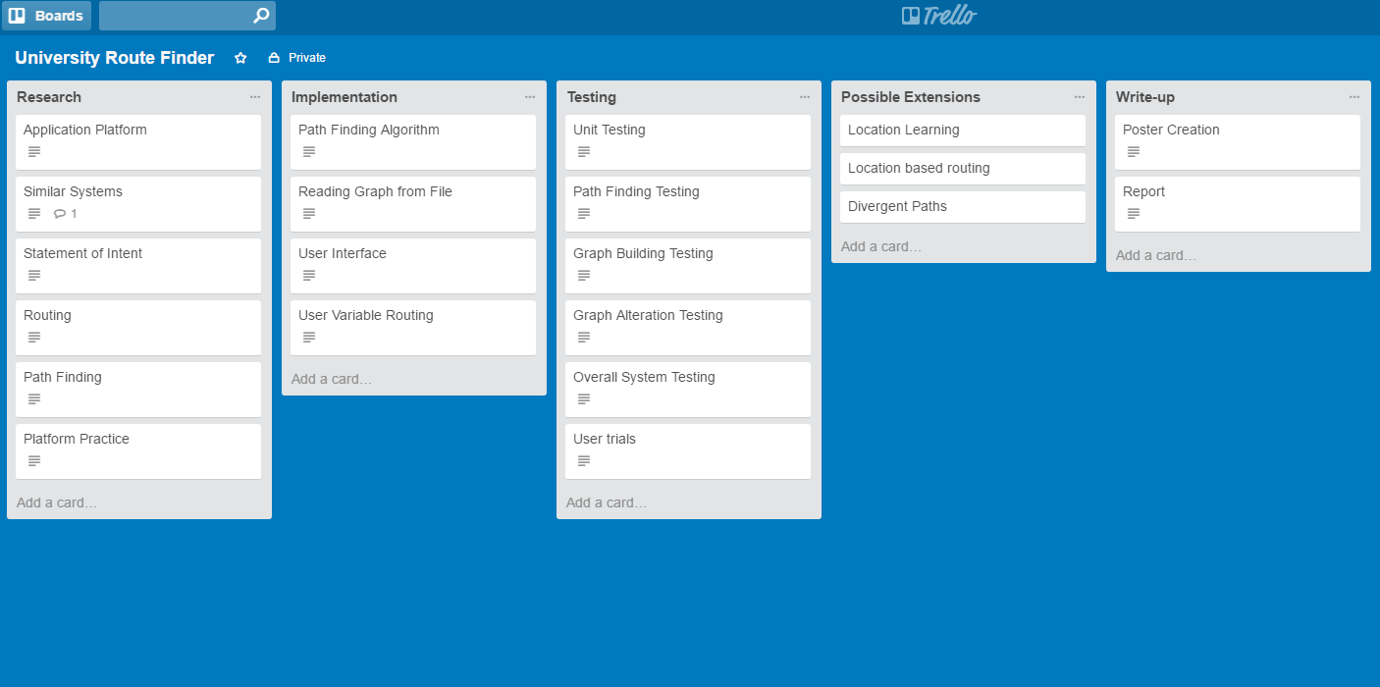

###### Figure 1 Trello Board for Original Project Plan [1]

The original project plan was kept for documentation purposes. However, the lists were copied to a new board which was updated as the project progressed. By regularly updating this new board the progress and aims of the project could be easily tracked.

Another important organisational tool was Ganttify [2] which can be used to take project plans developed in Google Calendar or Trello and create a Gantt chart to represent the plan. Gantt charts, created using Ganttify, for both the original and final plans can be found in Appendix 1 Original Project Plan and Appendix 2 Final Project Plan respectively.

### 2.3.2 Version Control

On any project with a sizeable software component using some form of Version Control is important. For this project Git was used as the Version Control System. Using Git gives a variety of benefits to the project, including being able to work on features in parallel on different branches. By using different branches for different features, the changes in one cannot negatively affect another. Importantly using Git also gives the ability to revert to a previous version of the software, if some change breaks key functionality. The revert ability means once a working version has been created that version can always be easily returned to at a later date.

Git requires a central server, to which work can be uploaded to or downloaded from, in order to provide the full level of functionality. The Git server for this project was provided by Github [3]. By using Github a copy of all the work is stored on their servers. The copy not only allows the project to be worked on from multiple machines; but also means that, provided the work is regularly pushed to the server, no large amount of work could be lost if anything was to happen to a work station.

### 2.3.3 Documentation

On a project of this size maintaining a record of the work that has been completed throughout is important. There are two ways in which the record of work has been maintained: writing a Logbook and using the Git Log. During the project whenever any design or research work has been carried out, notes and the purpose of the work has been documented in the logbook. In addition to this whenever anything is added to or changed in the project, Git requires that a message detailing the changes be written. The messages that have been added, known as the Git log, also form a record of work, as they outline what has been changed at each stage and frequently why the changes have been made.

# 3 Project Context

Before any development work could begin, several key questions had to be answered about how the project should proceed. To answer these questions investigations into several different aspects of the project were carried out.

## 3.1 Application Type

It was decided that the application should be able to be used on mobile devices, as mobile applications offer the greatest level of flexibility to the user. Creating the application for mobile means that a user could use the application throughout the day, and not just when they have access to a computer. Using the application throughout the day would be more convenient, as doing so allows the user to follow routes while they traverse the mapped area. Following routes while navigating the area, would require far less advanced planning for the user when compared to only planning routes while they have access to a computer. With the requirement that the application run on mobile devices, there are two main types of application that would be possible: a Web Application or a Native Application [4].

### 3.1.1 Web Application

Web applications are developed to be ran within a web browser, and are built as a website with special care taken to appear correctly on mobile devices. Running within a browser means that they can be used across virtually any device, including both mobile devices and more traditional computing platforms. Designing the webpage for mobile devices means they can be accessed and easily operated by navigating to the webpage on the phone.

### 3.1.2 Native Application

Native applications are built specifically for the mobile operating system being targeted. As native applications are platform specific, if the application is built for Android the application cannot be used on iOS or vice versa. To use a Native application, they are first installed from an OS specific store (either the App Store for iOS or the Google Play Store for Android). The application can then be launched from the home menu.

### 3.1.3 Comparison of Native and Web Applications

To decide between Native and Web Applications they must be compared on a number of attributes important to the project. The main issues that were considered along with discussion on which matches each requirement more closely for the project can be found in Appendix 3 Comparison of Native and Web Applications.

As can be seen from Appendix 3 Comparison of Native and Web Applications. Native applications have a number of advantages that are important to the project, particularly for the study into Location Services feasibility. There are two major choices to be considered when developing a Native Application: Android and iOS.

### 3.1.4 Android

Android applications are developed specifically for the Android OS and are widely available for download in the Google Play Store. Android phones are produced by a range of manufacturers including Sony, Samsung and HTC.

### 3.1.5 iOS

iOS applications are developed specifically for Apple’s mobile devices i.e. the iPhone and iPad. They are available for download on these devices through the App Store.

### 3.1.6 Comparison of Android and iOS Applications

A number of issues should be considered before deciding on a platform to build the application for. Several of the most important issues are examined in Table 1.

###### Table 1 Comparison of Android and iOS Applications on Key Issues

|  |  |  |  |  |
| --- | --- | --- | --- | --- |
| Issue | iOS | Android | Better for this project | Reason |
| Percentage of users worldwide | 13.9% [5] | 82.8% [5] | Android | Users are far more likely to own an Android phone and therefore be able to use the application. |
| Integration with mapping services | Wide support for many major mapping applications including Google [6] and Bing [7]. | Similar levels of support from the major mapping applications [8] [9]. | Tie | Both options offer similar levels of integration with popular mapping applications. |
| Availability | None. | Several devices of different sizes and features. | Android | Circumstances surrounding the project have dictated these are more easily available. |

For the reasons detailed in Table 1 the application will be developed as an Android application.

## 3.2 Possible Competition

Before creating the application, a study into what other options are currently available to the user should be carried out. By understanding what is currently available, differentiating the new application from the existing competition will become easier.

### 3.2.1 Standard Routing

There are many mobile applications which offer the user routes between a start and destination. With between one and five billion downloads, one of the most popular routing applications is Google Maps [10]. Google Maps currently offers routes between almost anywhere in the world, incorporating a variety of transport modes including: walking, driving or public transport. Despite Google Maps’ massive level of coverage, the level of detail within the maps is incredibly high. Many buildings even have internal floors that can be viewed.

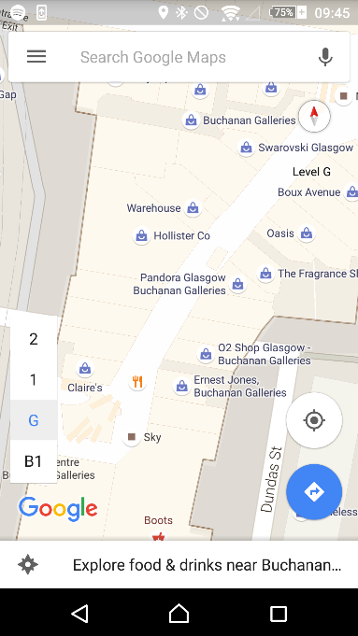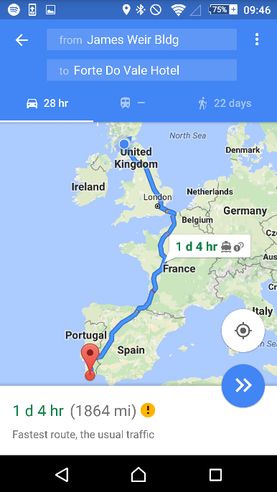

###### Figure 2 Examples of Google Maps Functionality

One limitation of Google Maps, is that the routing provided does not extend to the indoor portions of the maps. Despite occasionally giving very specific routes through buildings as options, Google does not allow routing to locations within a building. A sample of the indoor routing capabilities of Google Maps is shown in Figure 3.

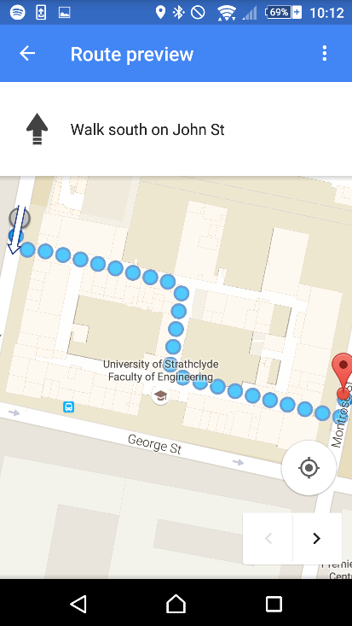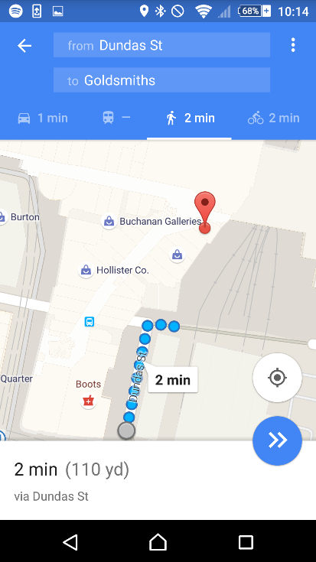

###### Figure 3 Examples of Google Maps Indoor Routing Attempts

As can be seen from Figure 3, Google Maps can recognise where certain indoor destinations are. However, instead of routing the user to their destination, the application will direct the user to their nearest entrance to the overall structure. Despite only routing to the nearest entrance, Google must have some knowledge of how to navigate within buildings. The routes provided will occasionally use corridors within a building in order to reach the other side.

### 3.2.2 Institutional Routing

There appears to be no major competitors within Institutional Routing. The Google Play store was searched for mapping applications that could cover routing within different institutions including: Oxford University, Cambridge University, St. Andrews University, Dundee University, The Louvre or the Queen Elizabeth University Hospital. Many of the institutions that were searched are notoriously difficult to navigate within for visitors. However, none of the institutions searched for have widely publicised applications available to help visitors navigate the institution.

The closest possible competitors that could be found are the Smithsonian Institution official application [11] and a non-official University of Glasgow application [12]. The Smithsonian Institution’s application splits the provided maps into two areas within the app which they refer to as: Map and Floor Plan. The Map section shows the locations of the buildings on a map using markers, and allows the user to tap the markers to discover the selected building’s name. The outdoor mapping functionality provided can be seen in Figure 4.

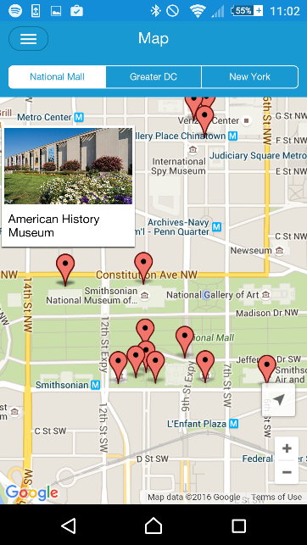

###### Figure 4 Smithsonian Institution Map

The Floor Plan section of the Smithsonian Institution’s application provides a series of menus which the user can navigate to plan their own route through the institution. However, there is no routing or interactivity available on these maps. A sample of how the Floor Plan section appears is shown in Figure 5.

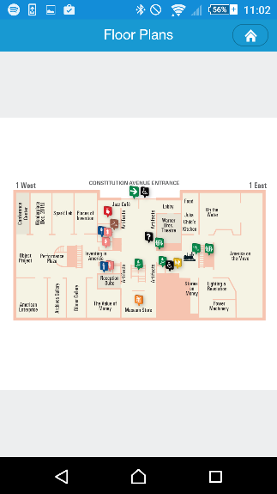

###### Figure 5 Smithsonian Institution Floor Plan

The only other possible competitor is named Glasgow Uni Map. Glasgow Uni Map provides the ability for the user to type in the name of a building within the campus, and for this building to be highlighted on the campus map. There are no additional features other than simply circling the building that the user has typed in. The application has been downloaded between one thousand and five thousand times, such is the need for institutional routing. The highlighted map produced by the application can be viewed in Figure 6 with building A3 highlighted as the Thomson Building was selected on the previous screen.

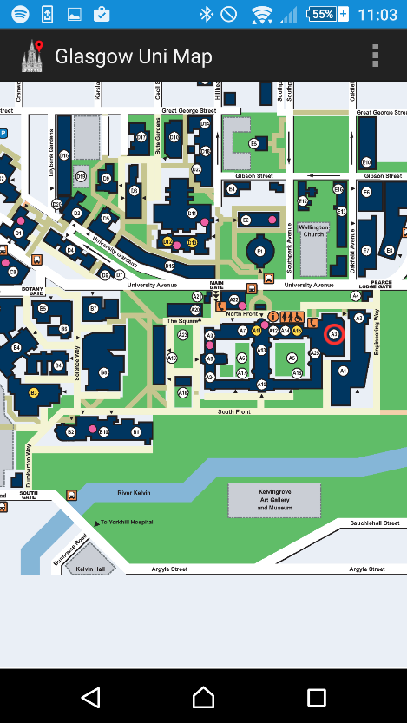

###### Figure 6 Glasgow Uni Map Screenshot

### 3.2.3 Disability Improvements

By adding the ability to avoid stairs within the application, the first step towards making the application a major asset to any Disability Service has already been made. As will be discussed in Chapter 8.2.1 Disability Services the disability related features would be improved given more time. This means that the application developed during the project could potentially compete with the services currently used by Disability Services within institutions.

According to Colin Flynn, a Disability Advisor for the Disability Service at the University of Strathclyde, the main technological service available to mobility impaired students to help them plan a route around the University is DisabledGo. DisabledGo provides information on many institutions throughout the country. By navigating a number of menus information can be discovered about the access to buildings, floors and some rooms. The information provided details whether there is ramp available or not, the steepness of either the stairs or ramp and lighting levels for the area.

Although this survey may be very useful for students when deciding upon whether or not to join a university; The survey is clearly impractical for students to use the service to plan routes around the university. All the survey could feasibly be used for is allowing the student to determine whether or not a short section of a route is accessible or not. Possible alternatives are not made easily available within the survey. An example of how the survey information is provided can be viewed in Figure 7.

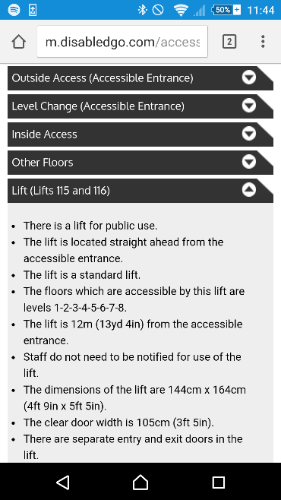

###### Figure 7 Disabled Go Strathclyde University Colville Building Survey Section

## 3.3 Static or Dynamic Routing

To determine whether the application should provide static or dynamic routing what both involve should be understood.

### 3.3.1 Static Routing

For the purposes of this report Static Routing will be defined as routing between two fixed points with the whole route available for the user to view. A popular example of this is Google Maps which can be found in Figure 8.

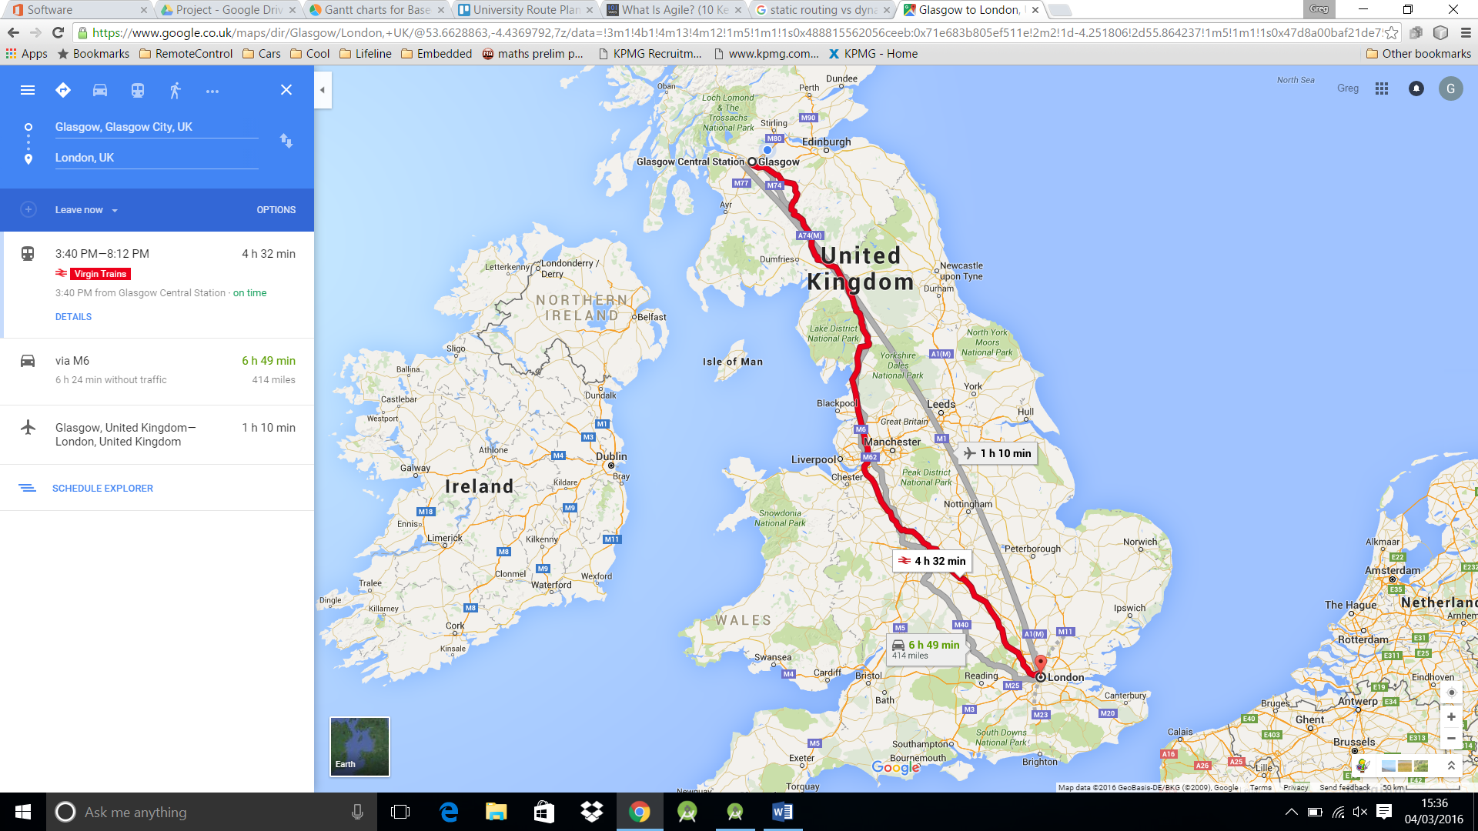

###### Figure 8 Static Routing Example [13]

### 3.3.2 Dynamic Routing

By comparison Dynamic Routing will be defined as routing from the user’s changing location to a fixed endpoint. Using the user’s location as the start, means as the user moves the route will automatically adjust to their new location. Dynamic Routing is used in Satellite Navigation systems or Google Navigation which can be viewed in Figure 9.

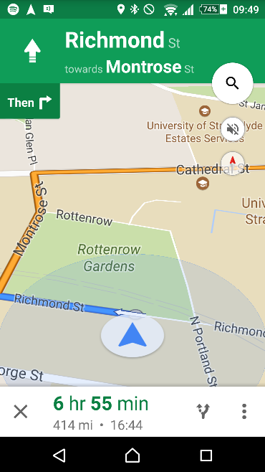

###### Figure 9 Dynamic Routing Example

With Dynamic Routing the view is also commonly more restricted, showing only a short section of the route at a time i.e. where the user is to go next.

## 3.4 Location Services

The main difference between the two types of routing discussed, is whether the user’s location is utilised to improve the user interface or not. In order to decide between them then, deciding whether using location services is feasible becomes important.

There are three main technologies which could be used to determine the user location: Global Navigation Satellite System, Cellular Positioning and Wi-Fi.

### 3.4.1 Global Navigation Satellite System (GNSS)

There are several GNSSs currently in operation. The most famous of these being the U.S. funded Global Positioning Service (GPS). However, there are others such as the Russian Federation’s GLONASS and soon the European Galileo [14]. The GNSSs were devised as a way to enable users worldwide to calculate their current location. The GPS system for example, comprises of twenty-four satellites continuously producing signals. The signals produced tell a user where the satellite is and provide highly accurate timing information about when the signal was produced. By listening to the signals generated by at least four of the satellites, and hence discovering their locations, the user’s location can be calculated. The user’s location is found by calculating the distance from each satellite, using the time taken to receive the signal, and combining that with the knowledge of the exact location of the satellites [15].

The accuracy of GPS is roughly 3.5m on the horizontal plane without using additional information. There are other systems which can be used in conjunction with GPS to provide up to millimetre accuracy. However, 3.5m should be accurate enough for this project [16]. The accuracy of Galileo is expected to improve to the centimetre range [17] once the system is completed in 2020 [18].

There are two main limiting factors: the accuracy of the GPS receiver in the user’s phone and that much of the time the user will be indoors. The accuracy of the receiver in a typical mobile phone is roughly 2-3m under good multipath conditions or up to 10m under bad multipath conditions [19]. Multipath is when the signal may reach the receiver via many paths. An example of multipath would be direct from the satellite compared to being reflected by a building in between the satellite and receiver. The weak multipath suppression available on mobile phone antennae means that the signal will degrade when near buildings. The app will always be expected to be running in an urban landscape therefore meaning the GNSS location may have quite a low accuracy. Receiving GNSS signals indoors can become a challenge, as the signal when received outdoors is already very weak. When compared with the background noise, the signal can be 10-100000 times weaker when indoors [20]. The reduction in the signal to noise ratio can make receiving the necessary information from four satellites at once particularly difficult. Without information from multiple satellites, determining location indoors via this method becomes virtually impossible.

### 3.4.2 Cell Tower Based Location

Location can be calculated using cell towers in a similar way to that of GNSS. Essentially, the phone sends a ping to the nearby cell towers and times how long the response takes to be received. If the locations of the cell towers are known, then an estimate of the phone’s location can be calculated using the respective distances from each cell tower [21]. An example of how this works can be seen below in Figure 10.

###### Figure 10 Cell Tower Triangulation

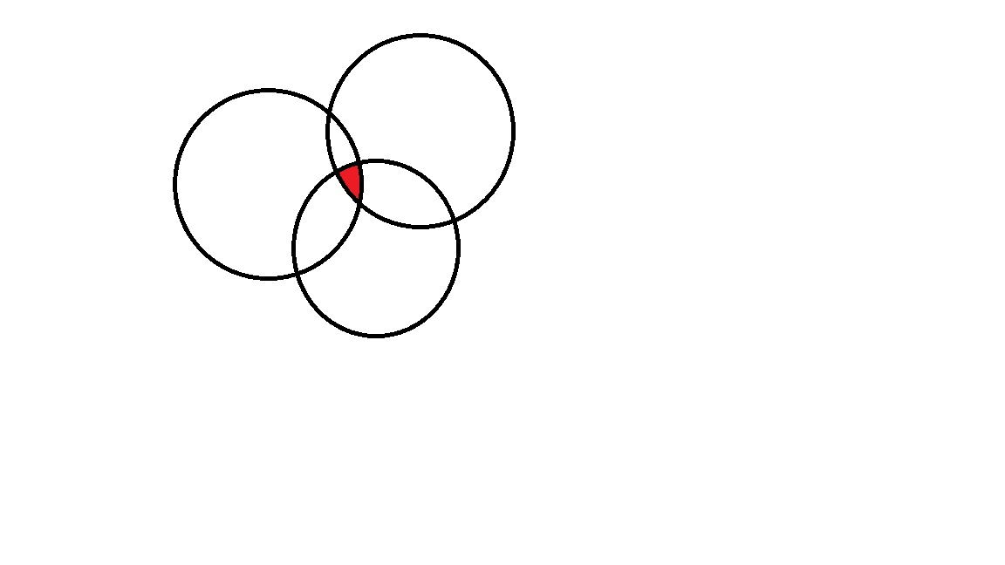

1

3

2

In Figure 10, the arrows represent the calculated distance from the cell tower. With only one cell tower response, the user could be anywhere in the surrounding circle. The user must be within the surrounding circle, as the furthest they could possibly be from the tower, with that response time, would be a straight line from the cell tower (the radius of the circle). However, there is no guarantee that the path being taken is a straight line. Instead the signal could be reflecting off of buildings or other materials, meaning the user could be anywhere within the surrounding circle. With responses from more cell towers the location becomes more accurate. As can be seen in Figure 10 with these responses the user could only be in the overlapping area from each circle.

Cell Tower Triangulation could potentially be a more reliable method of geolocation, as the calculated location still tends to be as accurate while indoors, presuming there is a mobile phone signal. Cell Tower Triangulation even works better in more urban areas where this application would be expected to be used, due to the higher number of cell towers [21]. There are some drawbacks in that to perform the triangulation, an accurate knowledge of cell tower locations is required. Cell Tower locations are not typically available publically making using Cell Tower Triangulation more difficult [22]. On average for example in the United States of America (USA) the average accuracy of a three tower triangulation is 0.75 square miles [23]. The accuracy of Cell Tower Triangulation is not at an acceptable level for this project.

### 3.4.3 Wi-Fi Based Location

In much the same way cell towers can be used to calculate the user’s location so can Wi-Fi base stations. By using easily available data such as signal strength, a rough estimate of distance from the base station can be calculated. If several base stations can be identified and their locations are known, then the user’s location can be calculated using triangulation.

### 3.4.4 Current Android Solution

Android as an OS, has several built in features for detecting the user’s current position and provides app developers with the opportunity to use this data. The location provided by the Android OS currently uses a combination of all 3 of the location services previously mentioned [24]. The accuracy while outside is reasonably high as can be seen in Figure 11.

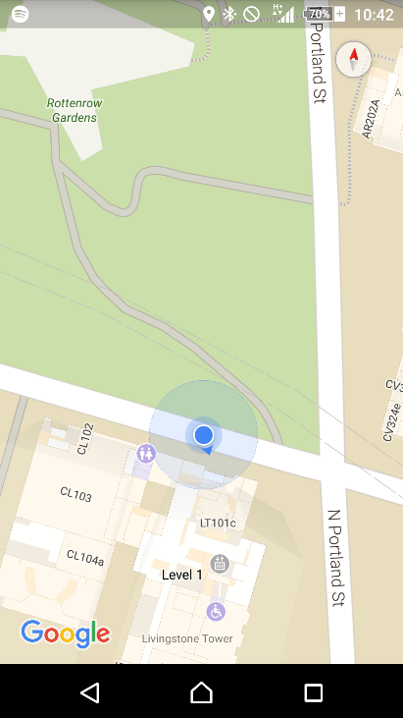

###### Figure 11 Outdoor Location Example

In Figure 11 the reported position is represented by a small blue circle. The small blue circle matches perfectly with the actual position of the user at that time. The accuracy of the reported location is likely due to the availability of a strong GPS signal, in combination with cell tower and Wi-Fi location services. When inside, the provided location services are far weaker as can be seen in Figure 12.

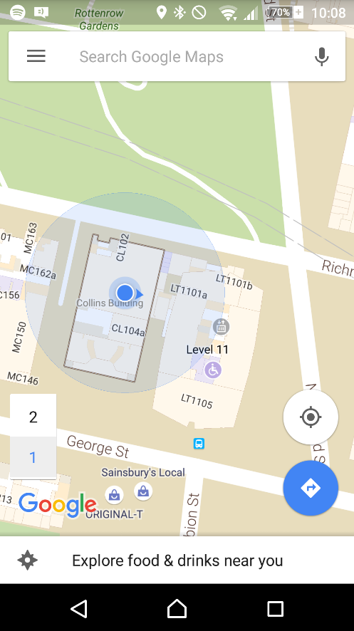

###### Figure 12 Indoor Location Example

In Figure 12, the reported location is again shown with a small blue circle. The reported location can be compared to the actual location, represented by the red circle, to show that when indoors there can be a large margin of error. The larger blue circle represents the area in which Google admits the location may fall within. Although technically the actual location does fall within this area, the data is still almost unusable from the perspective of the project. The area of uncertainty shown in Figure 12, covers an entire building as well as significant amounts of two neighbouring buildings. The large area of uncertainty means the provided location services are unlikely to be useful when trying to navigate within one building. The inaccuracy and uncertainty within the location is most likely due to the lack of a reliable GPS signal, combined with a low knowledge of the exact Wi-Fi and Cell Tower locations.

The reported position should be improving as Google is trying to advance their knowledge of Wi-Fi locations using their massive user base. The improvement is being carried out by taking the times when a user has a good knowledge of their own location using GPS, to send google information on the surrounding Wi-Fi signals and strengths [25]. The improved knowledge of Wi-Fi base station locations could eventually provide strong indoor locations worldwide. However, the currently available location is far to inaccurate for use in this project.

### 3.4.5 Improved Suggestion

As previously stated, the main problem currently facing indoor location services is a lack of knowledge about the locations of different Wi-Fi sources. Although steps are being made to try to improve the knowledge of Wi-Fi locations globally, within a smaller area that is to be mapped, such as a University campus, the problem becomes far more manageable. Within the smaller area the locations could be found manually, preferably by using documentation written during the installation of a Wi-Fi network. However, if an existing Wi-Fi map is not available, a new map could potentially be built by creating another application to track Wi-Fi locations.

## 3.5 Routing

In order to build an application that will provide a route for the user between their chosen start and destination, a graph representing the area to be mapped must be built. Once the graph has been built, a method for finding the shortest path between two nodes in that graph must be found. The shortest path in the graph can then be used to indicate the route that the user should follow.

### 3.5.1 Representing a Graph

There are three main ways of representing a graph within a computer system: Edge List, Adjacency Matrix and Adjacency List [26].

#### 3.5.1.1 Edge List

An Edge List is a list of all of the edges in the graph. The Edge List is a fairly easy to understand representation of a graph. However, the Edge List representation can be difficult to traverse during path finding algorithms. Indexing the information by edges rather than nodes, can make moving from one node to another more difficult. Each time the algorithm needs to check what edges are connected to the current node, all of the edges must be cycled through checking if they are attached to that node.

#### 3.5.1.2 Adjacency Matrix

An Adjacency Matrix consists of a matrix with the nodes along both axes, and the weight of the edge connecting them at the point where they meet. An example of this can be seen in Figure 13.

|  |  |  |  |  |  |
| --- | --- | --- | --- | --- | --- |
|  | A | B | C | D | E |
| A | Null | 2 | 4 | Null | 1 |
| B | 2 | Null | Null | Null | 2 |
| C | 4 | Null | Null | 6 | Null |
| D | Null | Null | 6 | Null | 5 |
| E | 1 | 2 | Null | 5 | Null |

4

C

6

5

D

1

A

B

2

2

E

###### Figure 13 Example Graph and Corresponding Adjacency Matrix

Adjacency Matrices are typically used in very densely populated graphs i.e. those with a lot of edges per node. Dense graphs are more appropriate for an Adjacency Matrix as the number of edges does not affect the storage space required. If the graph is particularly sparse, with each node having far fewer edges than there are other nodes, the Adjacency Matrix becomes increasingly inefficient. In the sparsest graphs almost the entire matrix is being filled with null values to represent no edge.

#### 3.5.1.3 Adjacency List

The Adjacency List is a method of storing the graph, in which a list of connected nodes is maintained for each node. Storing the data as an Adjacency List makes routing algorithms far simpler, as determining which nodes are connected to the node that is currently being examined becomes easier. Naturally, an Adjacency List does not support edge weights. However, support for edge weights can be added via a slight modification. By storing a list of edges for each node, instead of just the connected nodes, all of the benefits of an Adjacency List are available. However, storing edges instead of just the nodes, allows weights to be added to the edges. Allowing edge weights means that a weighted graph can be represented.

### 3.5.2 Path Finding

Once the graph representation has been constructed an algorithm for finding the shortest path must be implemented. There are many algorithms that have been developed for finding the shortest path between two nodes in a graph, and each have their own areas of expertise depending on the type of graph.

#### 3.5.2.1 Breadth-First Search

The Breadth-First algorithm starts at one of the two nodes the algorithm is to find the route between. From there the algorithm then moves out to all of the surrounding nodes and assigns them a value of one. Each of the nodes with a value of one are then examined and all of the nodes surrounding these nodes are assigned a value of two. The process continues until the algorithm reaches the desired node. The Breadth-First algorithm is guaranteed to find the path between the two selected nodes with the fewest number of hops. However, the Breadth-First algorithm, does not take into account edge weights.

By not taking into account differing edge weights, using the Breadth-First algorithm makes constructing a graph representing a campus to be mapped far more difficult. Without edge weights, each of the nodes would have to take roughly the same amount of time to walk between to produce an acceptable route. Making the nodes all take the same amount of time to walk between becomes particularly difficult when adding lifts to the routes. Waiting on lifts could potentially take several minutes, meaning each node would have to be several minutes apart. Making each node several minutes of walking apart is likely not possible within corridors with many turns. The only alternative would be to add conceptual nodes which the user could move through while waiting on lifts. However, the addition of these conceptual nodes is essentially adding weights in a very inefficient way.

#### 3.5.2.2 Dijkstra’s Algorithm

The main problem with the Breadth-First algorithm is that edge weights are not supported. Dijkstra’s Algorithm by comparison, will always find the shortest path in a weighted graph.

The algorithm works by starting at one of the two nodes that the path to be found is between, and marking the chosen node as examined. Each of the nodes that the examined node is connected to, then have a number associated with them, representing the weight of the edge taken to reach them. From there the node with the lowest associated number is marked as examined. All of the nodes connected to the newly examined node have the numbers associated with them updated. The numbers are updated to be the sum of the weight to the examined node plus the weight of the new edge. If this new associated number is higher than a previously associated number, the previous number is used. The process continues until the destination node is marked as examined at which point the shortest path between them has been discovered.

Dijkstra’s Algorithm is particularly useful as the time complexity is linear. Linear time complexity means that as the number of nodes in the graph increases, the time taken to find the path also increases linearly. Other path finding algorithms can have far higher time complexity than linear.

#### 3.5.2.3 A* Algorithm

The A* Algorithm is essentially a modification of Dijkstra’s algorithm that allows the shortest path to be found more quickly. The decrease in time taken to find the path, is achieved by adding a heuristic value to the comparison when deciding which node to examine next. An example of a possible heuristic value for a mapping application would be the straight line distance between each node and the current destination. Using the heuristic value means that when choosing which node to examine next, the algorithm would consider both the difficulty in reaching that node and how physically far away from the destination the node is. The result of using the heuristic value is that instead of spreading out equally in all directions like in breadth-first, or towards the easiest direction like in Dijkstra’s, the application would instead spread towards the destination quicker than in other directions. The algorithm relies on the fact that the heuristic function always returns a value less than or equal to the length of the shortest path from that node to the destination.

Calculating a heuristic value can be fairly simple for some applications. For example, a single level mapping application could use straight line distance fairly easily. However, a multi-level mapping application such as the one considered in the project, would face difficulties in implementing such a system. Calculating the straight line distance would be impossible without detailed knowledge of the heights of each building. Even if the straight line distance could be calculated it would likely be a very poor heuristic value. Using a straight line distance as the heuristic value would lead the search algorithm to move towards the destination node. However, in a multi-level system the quickest route may involve moving in the opposite direction, towards a staircase or lift. The A* Algorithm would still find the quickest route, but in many cases would likely be less efficient than Dijkstra’s Algorithm.

## 3.6 Software Engineering

To develop a system of this scale and ensure it is easy to maintain and extend it is important to try to use good software engineering practices throughout. Using good software engineering practices, should aid development and make testing easier by ensuring the software is flexible and forgiving of change. The various styles and patterns used in the project are as defined in the class CS409 Software Architecture and Design at Strathclyde University.

### 3.6.1 Architectural Style

An Architectural Style is the highest level programming choice to be made. The choice of Architectural Style, is concerned with how data and functionality should be separated. For example, the “Main Program/Subroutine shared data” style in which all of the data is available throughout the program and the functionality is separated into subroutines which can be called when needed. For this project, the architectural style is for a large part dictated by the decisions that have already been made. By choosing to develop for Android the implication is that the programming language to be used is Java. As Java is best suited to the Object-Oriented architectural style, it is this main style that will be used throughout the project. However, due to the way the Android OS and support libraries have been built up there, will also be aspects of Event-Based Implicit Invocation included throughout.

#### 3.6.1.1 Object-Oriented

The Object-Oriented (OO) architectural style relies on splitting the program into objects, instances of classes, which each have access to their own particular data and can perform their own actions. Objects can then communicate via method calls. Such an approach leads to greater levels of abstraction, meaning a change to one section of code will not dramatically alter other sections within the program. An instance could be if one object requests the quickest route between two nodes from a second object. The second object could be changed internally, to represent the graph differently or use a different path finding algorithm, but such a change wouldn’t affect the first class in any way provided the nodes to be passed in and the route returned still obeyed some kind of standard definition. The best way to create a standard definition is by creating an interface. An interface is a list of the publically available method calls that other classes can use to communicate with any classes implementing that interface. Many languages that support interfaces and classes, including Java, also support abstract classes which are to some extent an amalgamation of the two. They give implementations to some of their methods. However, leave it to subclasses to implement others.

#### 3.6.1.2 Event-Based Implicit Invocation

Event Based Implicit Invocation is similar to the OO style in many ways. However, instead of communicating between components via method calls, an object can register for updates based on a particular event. This is best exemplified during use of the User Interface (UI) objects provided in the Android Software Development Kit(SDK). When a UI object is created, a class which implements the provided interface can register for updates about events such as it being touched or swiped. Then, when the user next touches or swipes on that UI object, the registered object will be notified with relevant information such as the location of the touch.

### 3.6.2 Programming Style

A good Programming Style will provide a high-level guide to how the program should be laid out and how both functionality and data will be separated. There are many different programming styles which can be adopted. However, since re-usability was a major factor the decision was made that the Model-View-Controller (MVC) approach would be used.

Model-View-Controller divides data and functionality into three main sections: Model, View and controller. The Model should deal with everything programmatically; for example, in this project that would be the graph and path finding algorithms amongst other matters. The View should determine how that information is provided to the user; for example, a map or simply a list of instructions. Importantly outside the defined interface for communicating, these components do not rely on each other. An implication is the View could be changed entirely without any changes at all being necessary in the model. The Controller deals with user input and determines how that should affect the model. An instance in the project could be if the user selects a new room in some way, it is the controller’s responsibility to alert the model to this change in state. Again outside the well-defined interfaces, the controller should be able to be changed entirely without affecting either the model or the view.

By using this programming style it means components even at a particularly high level are highly interchangeable. An important point in case at some point during development a drastic change is required. A possible reason would be if, instead of using Google Maps, it was decided university blueprints would be more accurate. Even in this case, it would mean only the view would need to be changed, leaving two thirds of the code with no alterations needed despite the large change in functionality.

### 3.6.3 Design Patterns

Throughout programming, certain problems such as how to change algorithms during runtime appear again and again. Design Patterns are essentially proven solutions to commonly recurring problems. The use of design patterns provides the means to deal efficiently with such problems. Below is an overview of each of the design patterns which have been used throughout the project.

#### 3.6.3.1 Observer Pattern

The Observer Design Pattern is essentially a lower level version of the same principles the Event-Based Implicit Invocation Architectural Style was based on. Essentially, one component allows others implementing a specific interface to register for updates. Whenever this first object recognises a change of some sort it notifies all of those listening for updates. Using the Observer Pattern allows for two components which hold similar data to remain consistent while also staying loosely coupled. This design pattern can be seen most clearly in the sample UML diagram shown in **Error! Reference source not found.**.

###### Figure 14 Observer Design Pattern UML

Observer

*Update()*

**Update(State)**

Concrete Subject

*getState()*

Subject

addObserver(Observer)

notify()

Concrete Observer

The main advantage to this design pattern is that it very strongly decouples the concrete subject from the concrete observer allowing any changes to the concrete observer to be made easily. The main disadvantage, however, is that debugging potential problems may become more difficult as the flow of code becomes less obvious. There are two versions of the Observer pattern: the push model and the pull model. They both follow the same basic structure however with one major difference. The push model gives the Observer the information it requires when it is notified. By comparison the pull model simply alerts the Observer that something has happened. This means the Concrete Observer requires a reference to the Concrete Subject in order to determine what has changed and react accordingly. These differences can be seen clearly in **Error! Reference source not found.** with the aspects only in the push model shown in **blue** and those only in the pull model shown in *red*. The push model has the added advantage of also cleanly decoupling the Concrete Observer from the Concrete Subject.

#### 3.6.3.2 Adapter Pattern

The Adapter Pattern was designed to solve the problem in which two different parts of a system rely on different interfaces to do essentially the same thing. The pattern can be particularly useful when using frameworks or libraries which have already been developed, with new code that for some reason needs to have its’ own independent interface. There are two main variations of the Adapter pattern, Class and Object. As Class relies on multiple inheritance, a feature which is only available to a minimal extent in java, for the purposes of this project only the Object variation will be considered. The structure of the Adapter Pattern can be found in Figure 15.

Client

Target

Adapter

Adaptee

###### Figure 15 UML Representation of Adapter Pattern

In the diagram shown in Figure 15 the client needs to use the specific interface, Target. However, the necessary function is actually within Adaptee, which cannot implement the Target interface. In order to solve this a new class, Adapter, was created to take the data from Client and change it into the format needed by Adaptee.

#### 3.6.3.3 Template Pattern

The Template Pattern is used to define the order in which steps are carried out but leave the implementation of these steps open to change. Using the Template Pattern allows much of the outline and other functionality of an object to be defined in one class and for a certain part of the functionality to only be defined in a subclass. The Template Pattern can be found in Figure 16 UML Representation of Template Pattern.

Abstract Class

templateMethod()

fixedMethod1()

variableMethod()

fixedMethod2()

Concrete Class

variableMethod()

###### Figure 16 UML Representation of Template Pattern

In Figure 16 the abstract class would implement the template method and both fixed methods. The abstract class would then leave the variable method to be implemented by the subclass, or potentially subclasses. The template method would make calls to the fixed and variable methods in the order required, knowing that the concrete class will provide the variable methods. The concrete class then implements the variable methods, allowing the class to perform the necessary duties. Using the Template Pattern gives the benefit of allowing multiple classes, that differ in one area of their implementation, to be created quickly. For instance, in a drawing package the pattern would allow multiple shapes (the abstract class) such as square, circle or triangle (the concrete classes) to draw themselves differently; despite needing to perform the same actions before and after drawing, such as checking there was adequate space and alerting a listener to the change. The main disadvantage is that the functionality cannot be changed at runtime, once the class is created it will always perform that action in the same way.

#### 3.6.3.4 Strategy Pattern

The Strategy Pattern is used when a particular piece of functionality needs the ability to be changed at runtime. For instance, if a camera application used an algorithm to provide photographs with a filter applied to them; the Strategy Pattern would allow users to change which filter they wished to apply, while the application was running. Figure 17 shows a representation of the Strategy Pattern.

Context

Strategy

Algorithm()

Concrete Strategy A

Algorithm()

Concrete Strategy B

Algorithm()

###### Figure 17 UML Representation of Strategy Pattern

Essentially how this works is by having multiple classes implementing the Strategy interface. The Context can then change what functionality to use by changing which class it calls the method on. Frequently the context will have a method allowing another class to set the strategy. Using the Strategy Pattern means that the context doesn’t need any knowledge of the underlying implementation. As the context has no knowledge of the underlying strategies, new strategies can be implemented and used easily.

#### 3.6.3.4 Composite Pattern

The Composite Pattern provides the ability to treat a group of objects the same as an individual object. Being able to treat an individual object or a group of objects the same way is often beneficial within programming. An instance would be an application which controls a user’s lights. Grouping lights in an area, say a room, and being able to use functionality available for one light bulb (i.e. turn on, turn off or set timer), with the group of lightbulbs in a room would be useful. A representation of the Composite Pattern can be found in Figure 18.

###### Figure 18 UML Representation of Composite Pattern

 Client

 Leaf

 Composite

**Add(Component)**

**Remove(Component)**

 Component

Operation()

*Add(Component)*

*Remove (Component)*

As can be seen in Figure 18, the Composite Pattern has both the group of objects, the composite, and the individual object, the leaf, implementing the same interface, Component. The shared interface allows the client to interact with either the group or individual object in the same way. There are two variations of the Composite Pattern: safe and transparent. The methods only available in the safe variation are shown in **blue,** while those only available in the transparent variation are shown in *red*. Both variations have their disadvantages, the safe variation means that to add or remove elements within the composite, the client needs to directly communicate with the composite and not through the interface. Whereas the transparent variation, means that the “leaf” object will need to provide implementations for add and remove component, which is illogical. A light bulb can’t be added to a light bulb it has to be added to a group of light bulbs.

# 4. Design

With a software project of the scale required in a mapping application, a good software design is vital to ensure maintenance is possible. A strong design results in a program which can be easily understood by an experienced programmer. If the design can be understood easily extending the project at a later date becomes far simpler.

## 4.1 Initial High-Level Design

As previously discussed in Chapter 3.6.2 Programming Style, the high level design should follow the Model-View-Controller (MVC) programming style. To follow the MVC style successfully exactly what each subsystem will be responsible for and how they will communicate must be outlined. For a full overview the high level UML diagram is shown in

Appendix 4 Initial High Level UML Diagram.

### 4.1.1 Responsibilities

The model will deal with the state of the program i.e. what the currently selected start and end nodes are, what errors have occurred and what the current route is. The model will also be the only subsystem to deal with the data as a graph and will therefore be responsible for route finding.

The view will deal with how the current state of the program will be displayed to the user. For example, what rooms will be displayed, how the route will be given and what inputs will be taken from the user.

The controller will deal with reacting to user input and changing the model accordingly. When the controller is informed of some form of user input from the view, deciding in which way the user input will affect the model is the responsibility of the controller.

### 4.1.2 Communications

The communications between each of the three subsystems can be found in Table 2.

###### Table 2 High Level Communications

|  |  |  |  |
| --- | --- | --- | --- |
|  | Model | View | Controller |
| Model | n/a | Using the push variation of the observer design pattern. | n/a |
| View | n/a | n/a | View will hold a reference to Controller through the IController interface. |
| Controller | Controller will hold a reference to the Model through the IModel interface. | n/a | n/a |

Using the Observer pattern to communicate between the model and view keeps these two sub-systems independent from one another. The controller to view and controller to model communications will pass through interfaces. Using interfaces will aid decoupling. However, using the observer pattern does mean the model and view will be the most decoupled sub-systems. The difference in the levels of decoupling comes from the difference in how data is passed between the sub-systems. The model simply provides all of the data the view may require and allows the view to react accordingly. By comparison with the other sub-system interactions one system will pass specific data through with the instruction to perform some action. Not using the Observer pattern throughout is a compromise that has to be made however, because the links between the view to controller and controller to model are too complex to be broken down into an observer pattern easily.

## 4.2 View Design

The first issue that must be addressed when designing how the view should function is understanding exactly how the application will display the necessary information and interact with the user.

### 4.2.1 Displaying Necessary Information to The User

A decision was made early in the project that from an aesthetic point of view, showing the route on top of a pre-existing map would be preferable to creating a new map. Using a pre-existing map, would both cut development time and ensure that the output looked pleasing. As previously discussed there are many mapping applications which could be used or extended in order to provide the necessary functionality [8] [9]. As the application was being developed for Android OS the users would likely be familiar with Google Maps, which comes pre-installed on most Android phones. Google provides an extensive number of library classes to aid in the production of Android applications using their maps. These classes provide ways to add the map to a section of the screen and then perform a series of actions to the map such as moving location or drawing elements over the map. Google also provides a number of interfaces which can be implemented and then added as listeners to the map object. These listeners are one half of the Observer pattern and provide an easy way to react to the user performing actions on the map.

The decision was made that showing the entire map at once would be too overwhelming for the user, so instead the concept of planes was developed. A plane is an area of the map that can be displayed at one time. One plane would be either outside or a particular floor of a building. Each plane then has a series of endpoints and midpoints associated with it. Endpoints are where the user may be trying to reach, outside these could be a building or on a floor of a building these would typically be rooms. Midpoints are points that would be needed to follow the route, examples of which include entrances to rooms and points where corridors join. Midpoints are only useful to the user when they are on the route they are following. As a result of the relative usefulness of midpoints and endpoints, the decision was made that Endpoints would always be displayed when on the correct plane. However, midpoints would only be displayed as part of a requested route.

As discussed earlier, Google provides a variety of options for adding items to the map, two in particular stood out as ways in which to provide information to the user: Polygons and Polylines. Polygons can be drawn onto the map with a variety of design choices. Polygons are used within the application to display the Endpoints to the user. Polylines are essentially lines that can be drawn between two points on the map in a variety of colours. The decision was made that these would be drawn between the relevant midpoints to display the route to the user.

### 4.2.2 User Interactions

The main user interactions that will be required from the applications are: selecting the start and destination, starting routes and navigating around the map to discover the campus.

To select the start and destination nodes, the decision was made that a variety of options should be available to the user. One of the options provided to users is selection of the start and destination by tapping upon the desired endpoints. Using Polygons to display the endpoints meant that a listener could be added to the map to discover when endpoints are clicked by the user. Another option available to allow users to select an endpoint, is typing the name of the endpoint into one of the two provided text boxes. As the user begins to type, options will appear below which can be chosen from. Once the user has selected an endpoint, alerting the user that the selection has been successful is important. Two methods were employed to alert the user to a successful selection: changing the colour of the selected endpoints and ensuring the two textboxes display the names of the selected endpoints.

Once the endpoints have been selected starting routes is relatively simple. The only functionality required is a button which can be clicked in order to display the new route.

Navigating around the map was more difficult than providing the other user interactions. Although, at a basic level swiping to move, pinching to zoom and other navigation interactions are provided by Google. There are some more complex interactions introduced by the concept of planes. An instance of this would be when the application starts and the user is viewing the exterior of the campus. While outside the user requires a way to alter the view to display the interior of a building. To allow the user to move the view indoors an “In/Out” button was added. The new button is used to either move inside the last selected endpoint, if the user was currently viewing the outside plane, or return outside, if the user was currently viewing one of the indoor planes.

Displaying the interior of a building caused a variety of new problems. Once the user was viewing one of the internal planes, the map provided by Google was modified to show floor plans allowing the user to see corridors, rooms, etc. However, as Google only allows enabling all floor plans, the user could enter one building and then simply swipe to the side to view the inside of another building. Allowing the user to move between buildings, without passing through the outside plane, meant the application could not guarantee which building the user was viewing. Without a guarantee as to which building was being viewed, the application could not be relied upon to draw the correct additions to the map. Although Google does provide a listener to alert the application when a new building is focused, the information available from the listener is not sufficient to determine which building is being viewed.

To ensure the application could guarantee which building was being viewed, the decision was made that the user should not be allowed to view areas outside the selected building. Stopping the user moving outside the selected area is the responsibility of the CameraLimiter class. The CameraLimiter questions the IController to determine which building the user is currently viewing. If the user tries to move the camera to another area, the CameraLimiter will force the camera to pan back to the correct area.

When viewing internal planes, the user must be allowed to select which floor they would like to view. Google provides a level selector toolbar to allow the user to move between floors. However, Google does not provide a direct listener for the level selector UI element. Fortunately, when a user selects a new floor an IndoorLevelActivated event is created, for which a listener is available. Unfortunately, the IndoorLevelActivated event is also created for the default floor in every building when the floor plans are revealed, i.e. whenever the user leaves the Outside plane. The additional times the event is created, means that the listener needs the ability to be turned off in certain circumstances. Turning off the listener when moving between planes, stops the view forcing the controller to try to move to a variety of other floors.

Following routes using the standard method of moving into a building, then changing levels was deemed insufficient for following a route. In order to improve navigation while following a route, another Google Maps component was used: Markers. A Marker is an icon which can be added to the map and have a listener added to detect when the user clicks the Marker. The decision was made that these markers would be added at the first and last midpoints on the route for the plane being viewed. The listener was then used to allow the application to move to the next relevant plane when the Marker was selected by the user.

As discussed earlier, in order to react to user interactions a variety of Google Maps interfaces needed to be implemented. As reacting to user interactions is the Controller’s responsibility, ideally the controller should implement these new interfaces. However, many of the interfaces involve passing data such as Polygons or Markers to the class which implements them. Passing View specific components such as Polygons, would create an inappropriate amount of coupling between the View and Controller. If the Controller relied on Google Maps specific objects, changing the View in any serious way without dramatically changing the Controller would become impossible.

In order to reduce the level of coupling between the View and Controller, the Adapter Pattern was used. For each of the Google Maps specific interfaces, a corresponding class was developed. The corresponding class converts the View specific data into a form which can be understood by the Controller. The usage of the Adapter Pattern can be seen in Appendix 5 View UML Diagram, where IController is the Adaptee and the View (or more specifically the Google Maps components) are the Client.

## 4.3 Model Design

The model is responsible for storing the current state of the program and providing the route requested by the user. Storing the current state of the program is fairly simple and can be maintained using a series of set methods.

In order to provide the route, the graph must first be stored in a sensible manor. Recall from Chapter 3.5.1 Representing a Graph, there are three main ways to represent a graph. However, the Edge List is not appropriate as the graph will frequently be traversed by a routing algorithm, and the Adjacency Matrix representation is also inappropriate as the graph is particularly sparse. By eliminating the other two possible representations the Adjacency List variation covered in Chapter 3.5.1.3 Adjacency List becomes the obvious option.

As discussed in Chapter 3.5.2 Path Finding, there are many possible ways in which to find the shortest path between the nodes. However, during finding the shortest path there are steps which must be taken regardless of the path-finding algorithm used: checking the start and end nodes are valid, and alerting the listeners to the new route. As only a certain section of the functionality needs to be changed, and changing this functionality at runtime is unlikely to be useful, the decision was made that the Template Pattern would be used to provide the routing service. The usage of the Template Pattern can be found in Appendix 6 Model UML Diagram, where the Abstract Class is Model and the Concrete Class is DijkstrasModel.

Dijkstra’s Algorithm was chosen instead of the Breadth-First Search or A* Algorithm as both have severe limitations. The Breadth-First Search was not chosen as the graph would require weighted edges which is not supported within the Breadth First Search. The A* Algorithm was not used as doing so would require more development time, despite giving similar results to those produced using Dijkstra’s Algorithm.

To allow the graph to have elements that cannot be passed through - i.e. the concept of a building as opposed to actual corridors within that building. There needs to be a check placed on each node to ensure the node can be used. Adding checks upon whether or not a node can be used fits well within Dijkstra’s algorithm. The check can be added to only update the weights of surrounding nodes, if the node being examined passes the provided check.

Adding checks to the route finding algorithm, could be used to incorporate some form of disability aid into the application. To provide disability aid, further checks were added to exclude certain nodes when options were enabled. As a proof of concept for a much larger expansion, checks were developed allowing the user to choose whether or not they wished to avoid stairs, lifts or neither. As allowing the checks to be changed at runtime is important the Strategy design pattern was used. The usage of the Strategy Pattern can be found in Appendix 6 Model UML Diagram, with the Model being the context and the NodeCheck interface being the Strategy. The Concrete Strategies are hidden within the Controller for reasons which will become apparent during the next section.

## 4.4 Controller Design

The Controller’s main function is to add meaning to the user input. An instance of the Controller adding meaning to user input within the project, is when the user types in the first text box. Once the user has entered a new value, the Controller’s responsibility is to understand that the new value means the starting position has changed and to update the model accordingly. To add meaning to most of the user actions is fairly simple, and is just a matter of translating the action into an appropriate method call for the Model. However, two user interactions require more complex thought: moving planes and changing the routing modifiers.

The user can move planes in many ways including: moving level using the level selector, clicking the In/Out button or starting a route. As Google keeps track of what level was last viewed for a building, maintaining a record of which floor was last viewed for each structure is important. If a record of what floor was last viewed for each building was not maintained, when a user returned to a structure the wrong floor may be drawn. In order to maintain records for each building, the decision was made to create a collection of objects known as structures. There is a structure object created for each building which contains basic information, such as the name of that building, the last viewed level and the location of the building. The View can request the location data, via the CameraLimiter object, to ensure the app stays focused on the correct location. When an event requires a change in structure, such as moving building, the current structure variable is updated to indicate the new structure. Changing levels within a building can be handled by setting the level variable within that structure.

The Model currently deals with Route Modifiers via the NodeCheck interface. However, the user is to be allowed to choose multiple checks to be applied. There are two possible ways in which to allow the user to select multiple checks. One method, involves developing a separate concrete class for every possible combination of checks. The alternative is to treat the check as a group of checks. Developing a new class for every possible combination of checks would make extending the system far more difficult, as each new check would involve implementing exponentially more classes. The difficulty involved in extending a system in which each combination has a concrete class, implies the more elegant solution would be to treat the check as a group of checks. In order to allow the Model to continue to treat the process as one check, while allowing the Controller to treat the process as a group of checks, the Composite Pattern was used. The usage of the Composite Pattern can be found in Appendix 7 Controller UML Diagram with the Controller being the Client, the NodeCheck interface being the component, CompositeCheck being the Composite and BasicCheck, StairCheck and LiftCheck being the leaves.

The Composite pattern was used in the safe variation, which means that the Model needs no knowledge that the Composite Pattern is being used at all. The Controller handles all of the composition and creation, then simply passes the Model a check to use.

## 4.6 Data Requirements

The main problem with the design outlined so far is the massive amount of data required. To use the design as given above, requires three major groups of data: Endpoint Data, Midpoint Data and Link Data. Although none of the data is difficult to obtain, compiling the data into a useful form is time consuming.

To display endpoints in the way outlined in Chapter 4.2 View Design, requires a list of latitude and longitude pairs to draw the polygons. The list of co-ordinates would then have to be paired with the name of the room/building and the plane that the endpoint should be displayed on. Although for one endpoint a large amount of information is not required, the overall information required for endpoints does scale up significantly with the area being mapped. For example, the three floors and small subset of buildings used in the proof of concept data requires almost fifty endpoints.

The precise co-ordinates of the rooms and buildings can be easily acquired using the Google Maps web interface. The latitude and longitude of an exact point on Google Maps can be obtained by clicking on the point required and then copying the co-ordinates into a text file. However, using the Google Maps web interface to find co-ordinates is particularly time consuming and can take up to an hour to outline only six endpoints. Given that to map the entirety of the John Anderson Campus at Strathclyde University would require hundreds of endpoints, the length of time taken to outline endpoints using this method is concerning. In order to efficiently create the Endpoint Data a second application was created. The new application, Endpoint Builder, allows the user to enter the name and plane of an endpoint using text boxes. Once the name and plane have been entered, the user can then draw a shape on top of Google Maps to create a new endpoint. Endpoint Builder was used to construct the endpoints necessary to represent the exterior of several buildings within the John Anderson Campus, and a subset of the floors within these buildings.

As discussed earlier Midpoint Data is also vitally important to the success of the application. The Midpoint Data represents the points between which the route should be drawn. An instance of a midpoint could be where multiple corridors meet. Midpoints require similar data to endpoints, in that they need a name and plane on which they can be viewed. However, instead of requiring a list of co-ordinates, midpoints require only one set of co-ordinates. Creating the necessary Midpoint Data poses similar problems to creating the Endpoint Data. Even though each individual midpoint requires less co-ordinates to be drawn than an endpoint, there are far more midpoints to be drawn. In the subset of the John Anderson Campus created to form a proof of concept, over 150 midpoints were required.

In order to create the Midpoint Data for the proof of concept, another application was developed, named Midpoint Builder. Midpoint Builder allows the user to enter a name and plane for a new midpoint, then place it on top of Google Maps using a tap. As Midpoints are easily placed incorrectly, Midpoint Builder also gives the user the ability to move and rename newly placed midpoints. Once a new set of midpoints has been finalised, they are saved to a text file which can be added to the main application.

The final set of required data is Link Data, which defines the midpoints and endpoints that are connected. Link Data also defines the weight associated with each connection, to allow the routing algorithm to find the shortest path. As would be expected, there are far more links than both midpoints and endpoints combined. Due to the number of links required in an application of this size, creating the Link Data could be highly time-consuming.

In order to efficiently create the Link Data a fourth application was developed. The new application, Link Builder, allows the user to select two points and specify a weight for the new edge between them. Manually specifying the weight for all of the edges within the map would be highly time consuming. To avoid manually specifying the weight of each edge an algorithm was developed, to calculate approximately how long it would take to walk that distance.

To calculate the length of time it would take to walk in a straight line between two points, two pieces of information were required: a distance in latitude and longitude and the length of time taken to walk that distance. A straight line distance of 443ft was measured using Google Maps, between the co-ordinates (55.861574, -4.245258) and (55.861330, -4.243139). Using Pythagoras’ Theorem this gives a straight line distance of 0.0021330018752922. The average walking speed of the expected user is roughly 4.95ft/sec according to the Road Engineering Journal [27]. The average walking speed means the time taken to walk 443ft would be, 443/4.95 = 89.49 seconds. Dividing the time taken, in seconds, by the distance, in latitude and longitude, will give a ratio. The ratio is multiplied by distances, in latitude and longitude, to give an approximate length of time taken to walk between any two given co-ordinates. The approximate length of time taken to walk between the points is given as a default edge weight to the user when two points are selected.

## 4.7 Start Up Design

The data produced by the three auxiliary applications must be parsed and separated into the objects required by the Model, View and Controller sections. To create these objects and instantiate the other sub-systems, a Start-Up sub-system was created. By creating a Start Up section the other sections can be entirely decoupled from how the data is stored before loading. By decoupling the MVC components from the internal storage of data, the way in which the data is stored prior to loading could be changed entirely without any changes being needed to the MVC components.

# 5 Testing Strategies

As discussed during Chapter 2.2.4 Testing, the decision was made that contrary to traditional wisdom, the Full System testing would be performed during development with Unit and Sub-System testing coming later. The decision to invert the traditional order of testing was made for several reasons. However, the main reason was that Unit testing and Sub-System testing struggle with ensuring the View displays the necessary information in the correct manor. As the View was the first sub-system to be constructed, the decision was made that during development the application would be regularly loaded onto an android device, to ensure the output appeared correct. Once the View had been built, the Model and Controller could easily be tested using Full-System testing and the already functional View. Unit and Sub-System testing was then employed as a means of providing deeper assurances that each element of the system worked as expected.

## 5.1 Full System Testing

The tests that were performed during Full System Testing, evolved as the project progressed and features were added. In order to fully test the application, text files were developed for a subset of the University of Strathclyde. The subset used for testing included: the second floor of the Royal College Building, the first and eleventh floors of Livingstone Tower and the outside of six university buildings. As the project neared completion, several tests would be performed each time a change was made. These tests were performed in order to ensure the change hadn’t had an adverse effect on another area of the program. The tests performed after each change were:

1. Selecting an endpoint by tapping it.
2. Moving inside a building using the In/Out button.
3. Changing level inside a building.
4. Moving outside a building using the In/Out button.
5. Ensuring the buildings maintain the last viewed floor.
6. Ensuring building views are limited.
7. Selecting an endpoint using text entry.
8. Requesting a route that must cross several planes.
9. Ensuring routes between planes can be followed by tapping the markers.
10. Ensuring each of the route modifiers change the routes as expected.

A deeper description and final results of each of the full system tests, can be found in Appendix 8 Full System Test Results.

## 5.2 Unit Testing

Unit testing was used to ensure each individual component worked as was expected. To perform the Unit testing two frameworks were used: Junit and Mockito. Junit is a testing framework used to create classes within which unit tests can be developed. The unit tests each create instances of the class that is being tested. Methods can then be called on this class and the results tested to ensure they act as is expected. Each of the tests return either pass or fail and can be ran automatically to ensure no changes to the code break any of the functionality.

To create instances of the classes to test however, other classes need to be provided. If these other classes do not work as expected, then the test could fail even if the class being tested does operate correctly. Mockito, a mocking framework, provides the opportunity to create mock classes. Mock classes can be used to return specific values from method calls and verify which methods have been called. By verifying method calls and monitoring the results provided by the tested class, all external interactions from the class can be monitored. By monitoring all of the external interactions a more reliable test result can be obtained.

During creation of the unit tests for each component, the discovery was made that, as expected, significant portions of the view couldn’t be tested fully through unit testing. Several classes could not be tested as certain view components, Markers and Polygons for example, were marked final and so could not be mocked.

The unit tests can be found with the rest of the code at: <https://github.com/greglaw95/UniversityRoutePlanner>

## 5.3 Sub-System Testing

Sub-System Testing is essentially a larger version of unit testing. The main difference is that instead of testing one class, a group of classes are tested simultaneously. The Sub-System that was tested within this project was the combination of the model and controller.

The code can again be found at:

<https://github.com/greglaw95/UniversityRoutePlanner>

# 6 Performance Analysis & Predictions

If the application is to work over an entire campus or similar area, the application must be shown to function at an acceptable level as the map size increases. There are two main areas which have been identified as potential problems as the map size increases: the routing algorithm and drawing the map additions.

## 6.1 Routing Algorithm Performance

In order to test the plausibility of using the current routing algorithm on a much larger scale, a test was developed to monitor performance as the map size changed. The test was developed to create three different subsets of the overall graph created for the proof of concept. The time taken to calculate the route between each endpoint left in the system is calculated and an average produced. The results of the performance test can be found in Table 3.

Table 3 Routing Algorithm Performance Test Results

|  |  |  |  |  |
| --- | --- | --- | --- | --- |
| Test Description | No. of Endpoints | No. of Midpoints | No. of Links | Average Routing Time (ms) |
| Minus RC2 and LT11 | 15 | 72 | 97 | 1 |
| Minus RC2 | 25 | 95 | 153 | 2 |
| Minus LT11 | 35 | 141 | 184 | 5 |
| Full Graph | 45 | 164 | 240 | 7 |

As was expected from Dijkstra’s algorithm the time taken to find the route depends on the number of nodes in the system. The results of the test were plotted in Figure 19.

###### Figure 19 Routing Performance

As would be expected with Dijkstra’s algorithm the average time taken to find a route increases linearly with the number of nodes in the system. By continuing the relationship, a prediction on how the system will perform as the graph becomes larger can be made. The results of the prediction are shown in Figure 20.

###### Figure 20 Routing Performance Predictions

As can be seen from Figure 20 the algorithm should still provide the route within a suitable amount of time, less than half a second, for graphs of up to 10000 nodes. To represent a standard campus such a high number of nodes is unlikely to be needed. If more nodes are required, then a loading symbol could be used to increase the acceptable amount of time taken to find the route.

## 6.2 Drawing Performance

As the view depends on the concept of planes, only one plane will ever be shown at a time. Using planes means regardless of how big the overall map becomes, the time taken to draw the map additions will only ever depend on the maximum number of endpoints per plane. Due to the nature of the application the number of endpoints per plane is going to be a relatively low number, presumably either the number of buildings in the campus or the number of rooms on a floor. As a precaution a test was developed to find out how long it would take to draw a varying number of endpoints. The results of this test can be found in Table 4 Drawing Performance Test ResultsTable 4.

Table 4 Drawing Performance Test Results

|  |  |
| --- | --- |
| Number of Endpoints | Time taken to draw (ms) |
| 10 | 12 |
| 100 | 41 |
| 1000 | 816 |

The maximum number of endpoints per plane is likely to be significantly lower than the maximum value tested. As even with the maximum value tested the time taken is still acceptable, the drawing performance of the application is not a concern moving forwards.

The code created to perform both the routing and drawing performance analysis can be found in the classes RoutingPerformanceCheck and DrawingPerformanceCheck at:

<https://github.com/greglaw95/UniversityRoutePlanner>

In order for the tests to run, the Boolean variable testing must be to true in the MainActivity class.

# 7 Future Work

Although in the current form the application should work for a large scale campus, provided the data has been created using the auxiliary applications developed. There are certain features which could be added or extended to improve the finished product.

## 7.1 Improving the Route Modifiers Implementation

The Route Modifiers are currently able to identify stairs, lifts and could be easily extended to avoid other hazards such as hills. Route Modifiers could be incredibly useful as discussed later in Chapter 8 Future Applications. However, the method of implementing the Route Modifiers could be improved given more time. The current implementation relies on a naming convention, in which only nodes that are on stairs or lifts have the term “Stair” or “lift” in the name. The current implementation was created mainly as a Proof of Concept and shows that using route modifiers in a final application is possible.

As discussed during the design section, the checks can be modified easily without affecting either the Model or Controller, due to the modularity of the design. To improve the implementation of Route Modifiers, the only change outside of the check classes that would be required, would be to add extra fields and get methods to the Node object. The fields could then be set up with whether or not the node can be used under the different Route Modifiers on creation, allowing the NodeCheck objects to query the fields rather than check the names.

The difficulty involved in improving the Route Modifiers implementation, is not in the MVC components but in the Start Up section. To implement the Route Modifiers functionality properly, would require changing the file reading section to build the graph in the new format. The implication of changing the file reading functionality is that the text files used would then also have to be changed. Although the auxiliary applications created, Endpoint Builder and Midpoint Builder, could be altered to create the new text files. The time necessary to alter the applications and re-build the graph was not available.

## 7.2 Disabled Go Integration

As discussed in Chapter 3.2.3 Disability Improvements, there is a webpage named DisabledGo which performs a survey of many Institutions. The survey is made available to the public and details access to different floors or rooms.

One of the main problems with the Route Modifiers option is that by necessity sweeping statements are applied, such as the user wants to avoid all stairs. One possible improvement that could be made to the application, would be to provide the user with clickable markers at certain points on the route. When clicked these markers would provide a link to the relevant section on the disabled go website and an option allowing the user to determine whether that section was accessible for them. The application could then save this option for each point the user chooses and purposefully avoid that area from then on.

In the Model this would be implemented fairly easily. Once the Route Modifiers Improvement has been made it would simply require adding a new tag and new check. The View and Controller sections of the code would require marginally larger changes to allow the new functionality, but overall programmatically the work would be minimal. The main problem this new functionality faces would be the extra data that would be required. Each endpoint and midpoint providing the functionality would also require a web address with which to be associated. Adding a web address to each mid and endpoint could make building the maps take significantly longer.

## 7.3 Multiple Route Options

Currently most of the competing routing applications, offer multiple options for the route you can take between the selected points. Implementing multiple routes could be useful in the app for a variety of reasons. One such reason would be to show users alternative routes in case a particular path is blocked.

Multiple routes could be very simply added to the application because of the way the code has been designed. The View would need a very small tweak to change the section currently drawing a route, to instead loop through the provided routes drawing each in a different colour. The RoutePlannerState class could then be modified to carry this list of routes to the View.

Updating the View to display the routes as outlined above leaves only one problem for this extension: how to determine what these multiple routes should be? One possible way to determine the different routes would be to use the concept of Disjoint paths. Princeton University defines Edge Disjoint paths as paths which “have no edge in common” [28]. Using disjoint paths would be a relatively simple way to provide multiple routes. Implementing the disjoint method of multiple routes would involve creating a copy of the graph. Then once the shortest path had been found, likely using the existing algorithm, these edges could be removed from the graph and the algorithm could be repeated until no new paths could be found.

There are several problems with using disjoint paths to create the multiple routes. The first problem is that within buildings typically some edges have to be taken, for example the path out of a room with one door will always involve using that door. If the definition of disjoint paths was applied to the graph as it is built at the moment alternative routes would almost never be provided to the user.

Another way would be to use the tags included during the Route Modifiers extension, to provide multiple routes based on different criteria. An example of using these tags would be to provide the shortest path in a traditional timing sense, the path which spent the smallest amount of time on stairs and the path that spent the smallest amount of time outside. Creating multiple paths based on different criteria the user may be interested in would provide a more meaningful choice.

Implementing an algorithm to provide these different routes should be fairly simple and would only require editing a small section of the Model. To change the Model to deal with the new functionality, would simply involve changing the section in which the edge weights are used to calculate the shortest path. To find the path which spends the least amount of time on stairs, would mean using zero as the edge weight for most edges and only using the standard edge weights for the edges which involve stairs. A more lenient system could also be developed which simply applies a stronger weighting to using stairs than not using stairs. By applying a stronger weighting system to stairs instead of only weighting the edges on stairs, the algorithm would produce a path which would still use stairs if it made the journey significantly shorter.

## 7.4 Reaching More Platforms

In order to reach platforms other than Android, such as iOS, the application would have to be rewritten in another language. This would not be as difficult as starting again as although iOS uses a different language, Objective C instead of Java, both languages strongly support and encourage the Object Oriented (OO) Architectural Style. As Objective C supports OO concepts this means the majority of the design could be used without any changes. The only changes that would really be necessary within the Model and Controller sections of the application, would be language specific implementation changes. The View section of the application however, would require significant changes as it currently relies heavily on the Android provided User Interface (UI) components. To port the View section to run successfully on iOS would require research into how to use the iOS provided UI components and integrate with Google Maps from an iOS device.

An alternative to manually creating the iOS application from the existing design, would be to use a transpiler. A transpiler is a specific type of compiler, which changes a program written in a language of one level of abstraction into another language with the same or similar level of abstraction [29]. Using a transpiler could potentially create the Objective C code directly from the already developed Java.

There is a powerful and widely available transpiler named j2objc which was developed by Google and should be able to automatically create the Model and Controller classes. J2objc was used to help create Google’s new e-mail client [30]. There are potentially some problems with using a transpiler such as the generated code being more difficult to understand. However, the time which would be saved in development mean it is an option that should be considered.

## 7.5 Release and Updates

The final release of the application would most likely be as part of a larger application. The main use for the mapping application would be as a service provided by an institution. As a result, including the mapping application as a section within the institution’s own application would likely be the best way to provide the service to users. Adding the application to another, would involve more work as it would require a way to navigate between the rest of the larger application and the mapping application.

Android applications traditionally work on the concept of activities a self-contained piece of functionality displayed on one screen. The entire mapping application was developed as one activity as there are only very minimal changes to the display throughout. With only one activity adding the mapping section to an already existing Android application should be fairly easy.

Updating the application once it has been published is very simple using the Google Play Store framework. To do so the version number simply has to be incremented and a new compiled version of the code uploaded to Google. The application will then automatically update for all users who have allowed automatic updates. For those users who have not enabled automatic updates, the new version will be available for them to manually update on the Google Play Store.

As updating the application is so easy, there is the potential to release the routing application simply providing outdoor directions to start with and then gradually adding a building at a time through updates. By releasing the map as new sections are available, users could potentially have access to the system sooner.

## 7.6 Adding Location Services

Adding location services would be a potentially long and difficult extension however, potentially very rewarding to the end user. Adding location services as a way to determine the start point of the route would allow users who don’t know their current location to navigate around the university. Location services could also potentially be used to update the route as the user attempts to navigate the university. By updating the route as it is followed, the user would be able to understand the route more easily and navigate around potential obstructions by simply walking away until the route changed.

As discussed during Chapter 3.4 Location Services, the best way to provide Location Services within the application is using a combination of the already available technology and Wi-Fi based location. To do so the Google provided location will be constantly checked. If the accuracy level is above a certain value, it will be assumed the user is outside and the Google provided location will be used. If however, the accuracy level falls below that value, then the Wi-Fi hotspots the user’s phone is aware of and their relative signal strengths will be used to calculate an approximate location using triangulation as discussed in Chapter 3.4.2 Cell Tower Based Location.

The functionality would fit well within the existing design. Creating a new special case node, named My Location, would allow the user to select their location using the text boxes, in the same way they can currently select a room or building. The location node would implement the INode interface, allowing the model to treat the location node the same as any other node. However, hidden behind the interface would be a complicated series of listeners waiting for a location change from the currently preferred method of detection. When the location changes, the node would detect which of the already existing nodes in the graph the user is closest to. The edges of the location node would then change to mirror the edges of the node closest to the user. Mirroring the edges of the node which most resembles the user’s location, allows the location node to constantly integrate with the graph regardless of where the user is.

There would also need to be slight changes to the View to incorporate the location services functionality. The changes needed within the View would be relatively simple however, only requiring that if the View recognises the start or destination to be “My Location” then a marker should be drawn at the node nearest that location.

# 8 Future Applications

There are many potential uses for the application in its’ current state, provided the additional data can be obtained, and even more if some of the progress alluded to in the future work section is completed.

## 8.1 Without Extensions

The application could be useful in a wide variety of circumstances, to many different departments within the University of Strathclyde. With a different data-set all of the applications discussed could also be applicable to any institution, for which indoor maps are available on Google Maps.

### 8.1.1 Recruitment

The University of Strathclyde faces an issue when trying to attract new students, during events such as open days. Although campus maps are provided and signs are placed throughout the University, finding rooms in which events are being held can still be difficult for prospective students. Making this application widely available to prospective students would enable them to find the rooms far more easily. In addition, the application may even make potential students more comfortable joining the University, if they feel they will be able to navigate the campus more easily.

### 8.1.2 Conferences

As with any conference, attendees will not be expected to be familiar with the campus. A lack of familiarity with the campus can make navigating the university difficult. Supplying a version of the mobile application created during this project, could make navigation far simpler for the attendees. A room number could simply be given to the visitors and with the application, the assumption could be made that they would easily be able to find the room.

### 8.1.3 Deliveries

The application is easily envisioned in a delivery setting. According to Derek Glenn, who organises student orders within the department of Electrical and Electronic Engineering, deliveries are frequently made to the wrong locations within the university. Delivery drivers will likely not be familiar with the campus, making finding a particular room very difficult. Making a version of the mapping application available publically, could allow the delivery to be made more easily to the correct location. The “avoid stairs” option may also be particularly useful if the object being delivered is difficult to manoeuvre.

## 8.2 With Extensions

By altering the application very slightly and improving upon certain aspects, there are even more usages that can be envisioned.

### 8.2.1 Disability Services

By adding the ability to avoid hills or other such obstacles, as well as the already implemented “avoid stairs” feature, the application becomes very powerful in allowing mobility impaired users to navigate around the university. Currently, navigating around large campuses such as the John Anderson campus at Strathclyde can be very difficult for students, staff or visitors if they can’t use stairs or climb steep hills.

The application could be distributed to mobility impaired visitors, allowing them to independently plan routes through the university. As discussed in Chapters 7.1 Improving the Route Modifiers Implementation and 7.2 Disabled Go Integration, with further improvements the application could feasibly be used to allow mobility impaired users to build up routes based on their individual abilities.

### 8.2.2 Fire Safety

Within non-domestic properties in Scotland, and indeed most of the United Kingdom, the responsibilities of those in control of the premises includes providing evacuation plans for all of the people in the building [31] [32]. The evacuation plans are typically provided in the form of a Personal Emergency Egress Plan (PEEP) for individual disabled visitors or through the creation of standard PEEPs in busy public areas. For a large campus the creation of these plans potentially means detailing the quickest route outside, from every room in every building, under a variety of different conditions, such as avoiding lifts or stairs. Creating these plans could potentially take a long time. However, with a very small modification to allow the destination to be any external location, the fire safety officer could potentially create the PEEPs far quicker. Adding an additional option to allow the user to select an area to avoid, would essentially create dynamic PEEPs constantly available on the users’ phone.

# 9 Conclusions

Throughout the project, an application capable of finding routes within a large campus and displaying the results to the user has been developed. The application has been proven to be capable of handling such a task in a variety of ways. A proof of concept data-set was created, to show the application functions correctly with a small sub-set of the John Anderson campus at the University of Strathclyde. Several tests were performed using the proof of concept data and the application was found to function correctly using the sub-set of required data. In order to consider the effects of a full scale data set, additional tests were developed. The ability to find the shortest route and display the route to the user were both considered under larger scale data sets. The predictions made from the tests suggest the application would be able to function correctly over a full sized campus.

The possibilities of adding Route Modifiers and Location Services to the application were considered in detail. A proof of concept implementation of using Route Modifiers was included in the application, to show the full functionality could be included in a final product. A discussion into how the final implementation of Route Modifiers could be implemented was also examined. A study into the feasibility of including Location Services in the application was carried out. How to include Location Services within the design was also considered. However, further work would be required in order to determine for certain, whether the inclusion of accurate Location Services is possible.

# Appendices

## Appendix 1 Original Project Plan

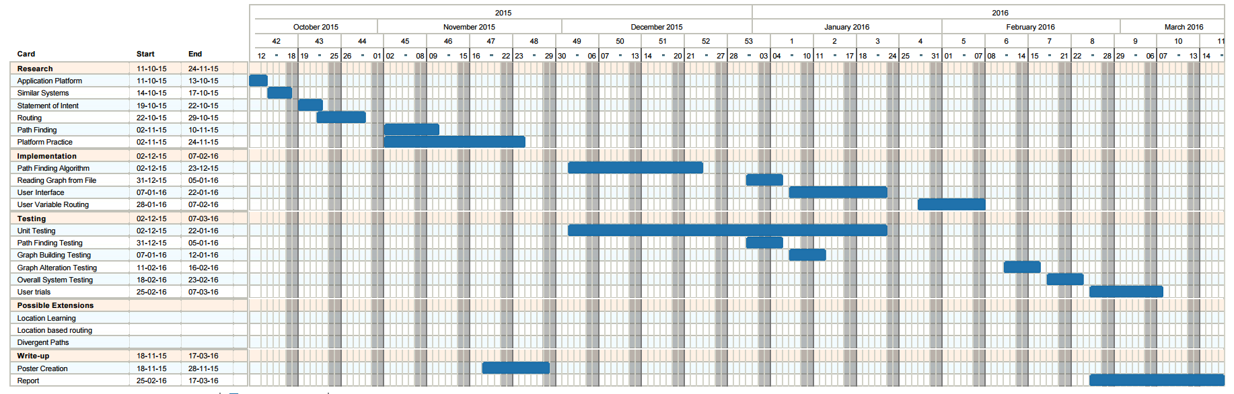

This Gantt Chart was created using a combination of Trello ([www.trello.com](http://www.trello.com)) and Ganttify (www.gantt-chart.com)

## Appendix 2 Final Project Plan

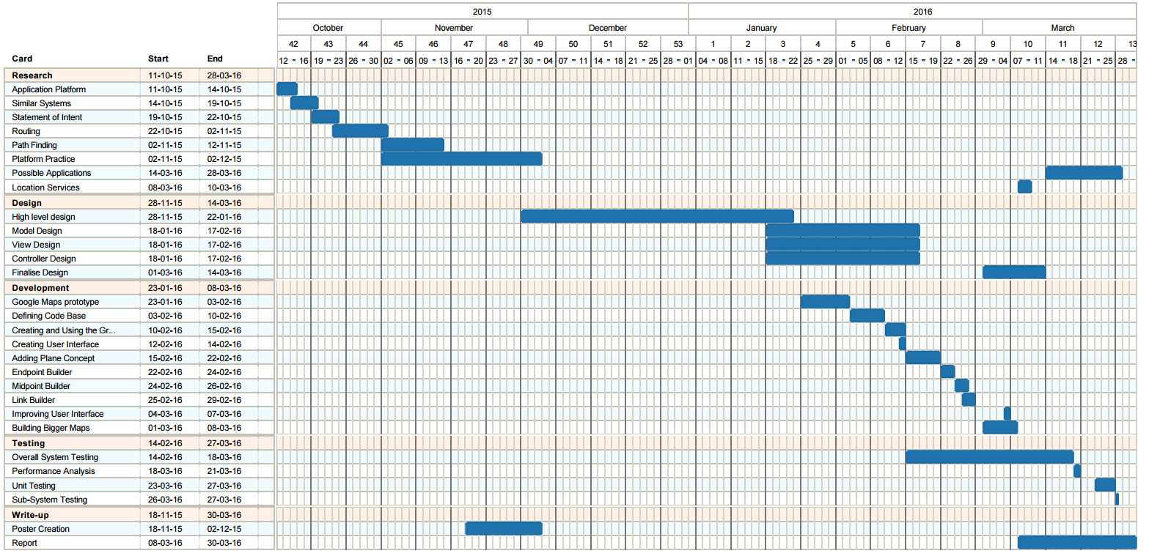

This Gantt Chart was created using a combination of Trello ([www.trello.com](http://www.trello.com)) and Ganttify (www.gantt-chart.com)

## Appendix 3 Comparison of Native and Web Applications

|  |  |  |
| --- | --- | --- |
| Performance | Portability | Issue to compare |
| Developed specifically for each platform which means greater performance. | Can only be used on the OS it was designed for. | Native Application |
| Lower performance. | Can be used on virtually any Operating System that includes support for a web browser. | Web Application |
| Native | Web | Better for the project |
| Performance may be an issue as the size of the map increases. Although this is also an issue for the choice of routing algorithm it makes sense to make the later choice easier. | If this was to be released it would be important for as many students to have access to it as possible. Although multiple Native Applications could be created it would be far easier to have one Web Application | Reason |
| Performance | Portability | Issue to compare |
| Developed specifically for each platform which means greater performance. | Can only be used on the OS it was designed for. | Native Application |
| Lower performance. | Can be used on virtually any Operating System that includes support for a web browser. | Web Application |
| Native | Web | Better for the project |
| Performance may be an issue as the size of the map increases. Although this is also an issue for the choice of routing algorithm it makes sense to make the later choice easier. | If this was to be released it would be important for as many students to have access to it as possible. Although multiple Native Applications could be created it would be far easier to have one Web Application | Reason |

## Appendix 4 Initial High Level UML Diagram

## Appendix 5 View UML Diagram

Note: Each of the adapters have their own google interfaces however they were treated as a block to simplify the diagram

## Appendix 6 Model UML Diagram

## Appendix 7 Controller UML Diagram

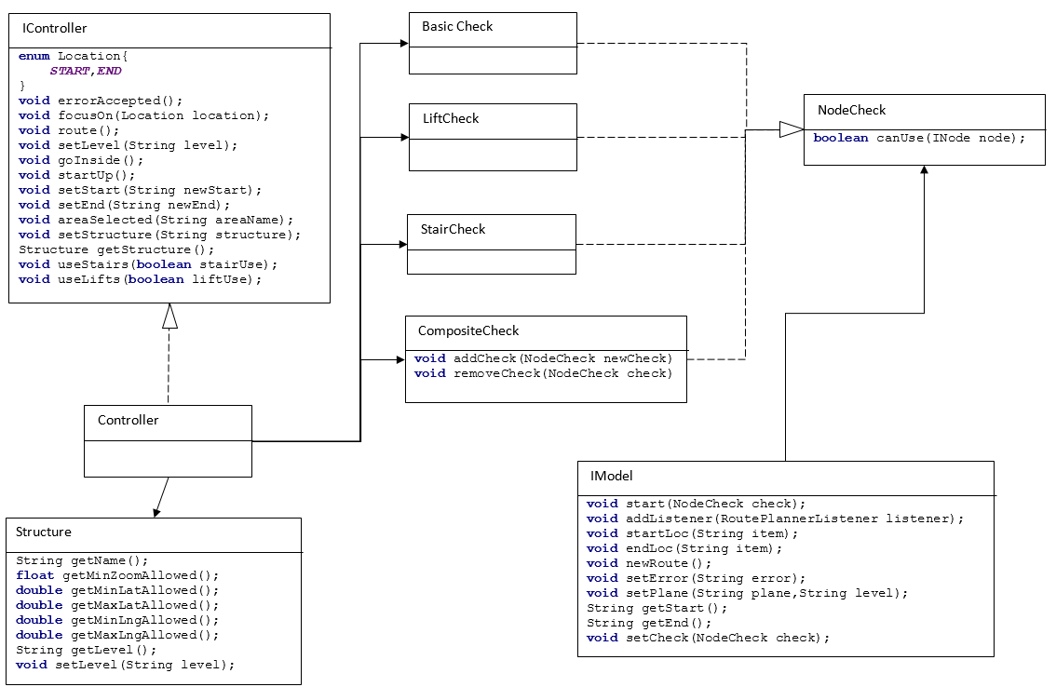

## Appendix 8 Full System Test Results

### Test One

Selecting an endpoint by tapping it is a fairly quick test and simply involves loading the application and tapping one of the endpoints that is displayed. The successful result of this test is shown in Figure 21 with before shown on the left and after on the right.

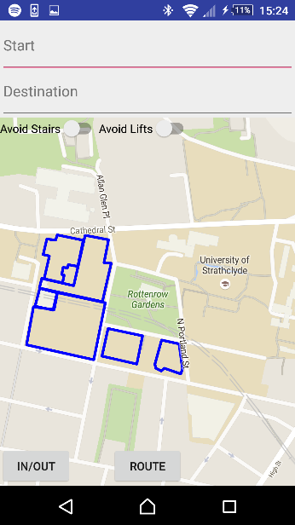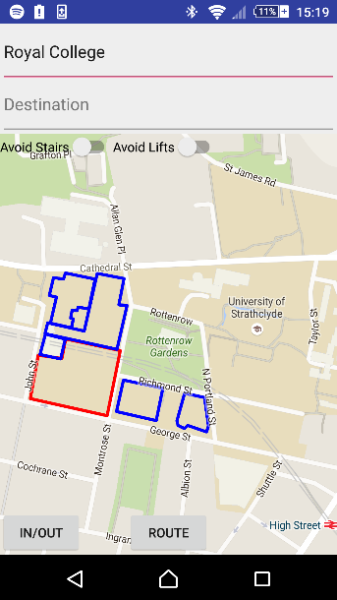

###### Figure 21 Test One Result

### Test Two

Moving inside a building using the In/Out building can follow on from Test 1 by simply clicking the In/Out button once a building has been selected. The successful result of this test is shown in Figure 22.

### Test Three

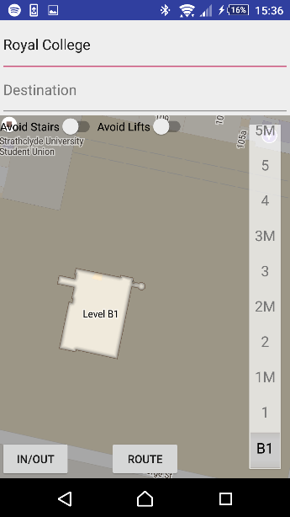

###### Figure 22 Test Two Result

Changing a level inside a building can be tested by moving inside a building and then selecting another floor from the floor picker. The successful result of this test can be seen in Figure 23.

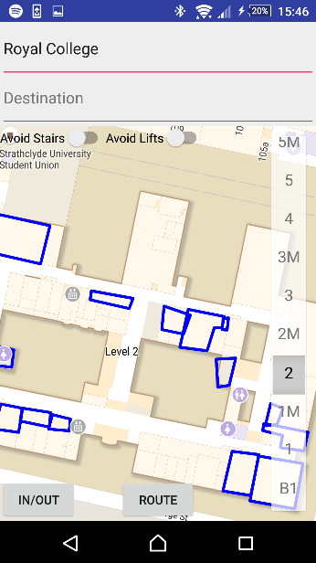

###### Figure 23 Test Three Result

### Test Four

Moving outside of a building requires pressing the In/Out button while viewing the interior of a building. The successful result of this test can be seen in Figure 24.



###### Figure 24 Test Four Result

### Test Five

Ensuring the buildings maintain a knowledge of the last viewed floor involves: moving into a building, changing the floor, leaving the building, then returning and checking the level is the same. If the tests have been performed in order this simply involves returning to the inside of the previous building. The successful result of this test can be seen in Figure 25.



###### Figure 25 Test Five Result

### Test Six

Ensuring building views are limited involves: viewing the inside of a building, scrolling outside the bounds of that building and ensuring the camera returns to that building. This can be proved by zooming further out than is allowed simultaneously as well to ensure it is also limited correctly. The successful result of this test can be found in Figure 26.

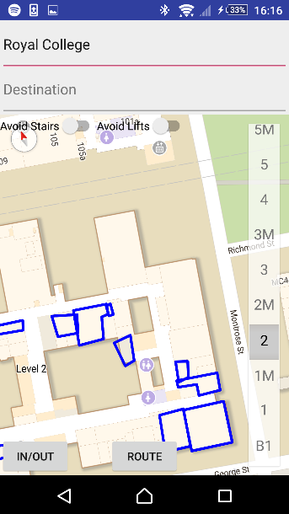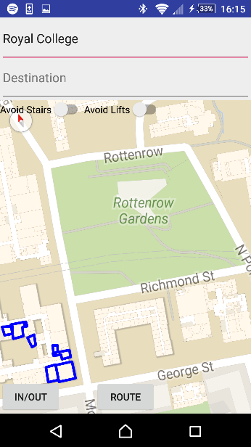

###### Figure 26 Test Six Result

### Test Seven

Selecting an endpoint using text entry involves: beginning to type the name of the endpoint and selecting the name from the menu that appears. The camera should then pan to that endpoint and show it is selected. The successful result of this test can be found in Figure 27. Please note that a dropdown does appear when the user begins typing however does not appear on screenshots.

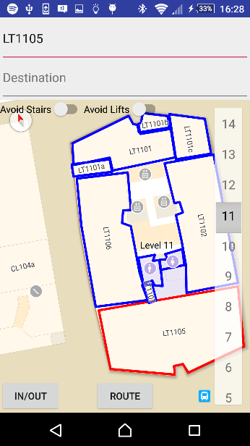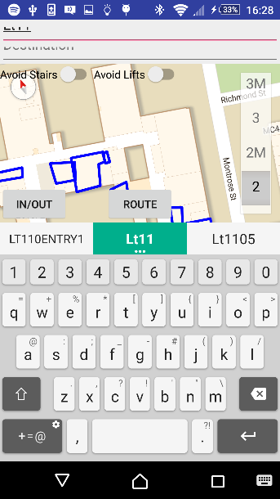

###### Figure 27 Test Seven Result

### Test Eight

Requesting a route which must cross several planes involves choosing two nodes that would require the route to pass through several planes and clicking route. The successful result of this test can be found in

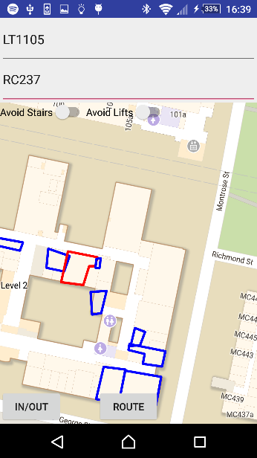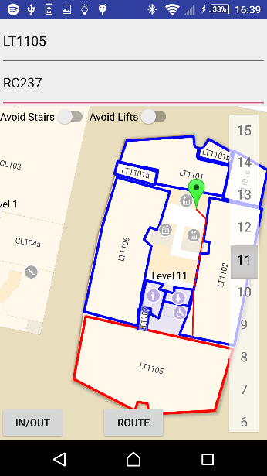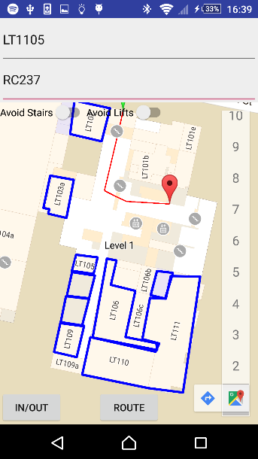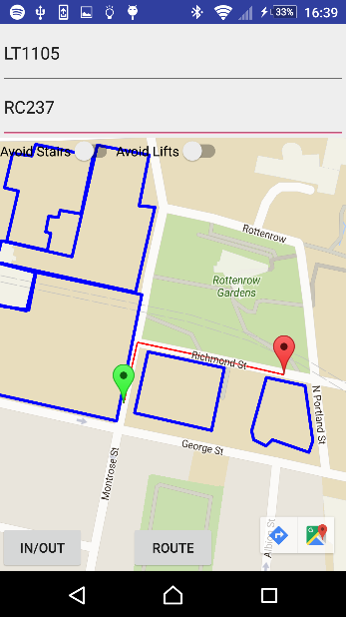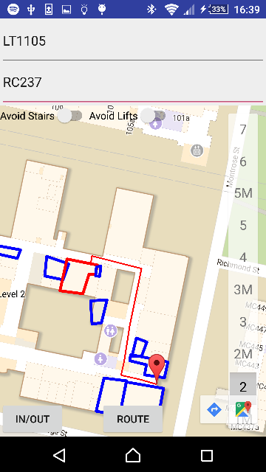

###### Figure 28 Test Eight Result

### Test Nine

The ability to follow the route using markers requires requesting a route that moves between planes then clicking the marker that appears. The application should then switch to the next or previous plane depending on the colour of the marker. The successful result of this test can be found in Figure 29.

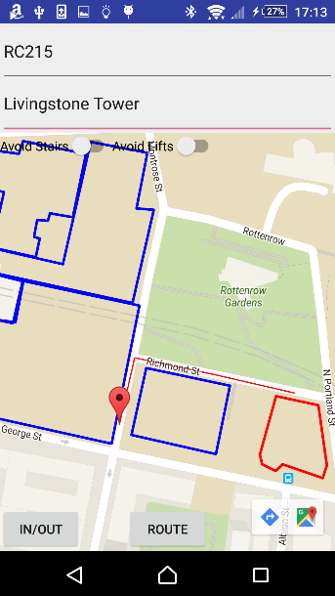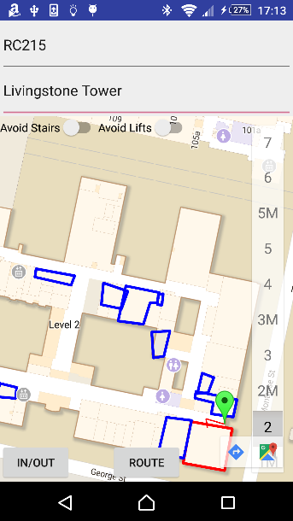

###### Figure 29 Test Nine Result

### Test Ten

Testing each of the route modifiers changes the route as is expected involves choosing a route which could potentially use either stairs or lifts. Then requesting the route with every possible combination of route modifiers enabled and ensuring the routes change in an appropriate way. A route with neither modifier enabled can be found in Figure 30.

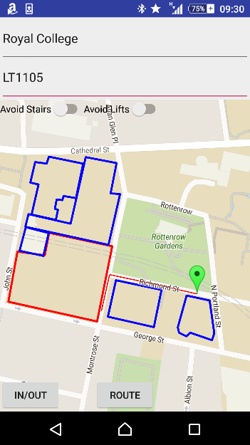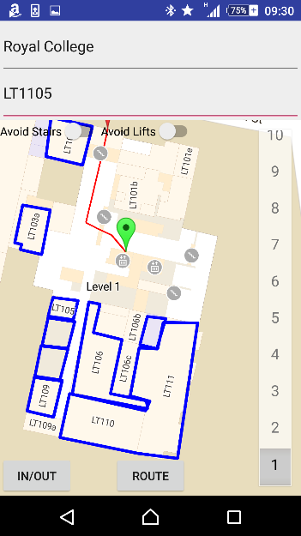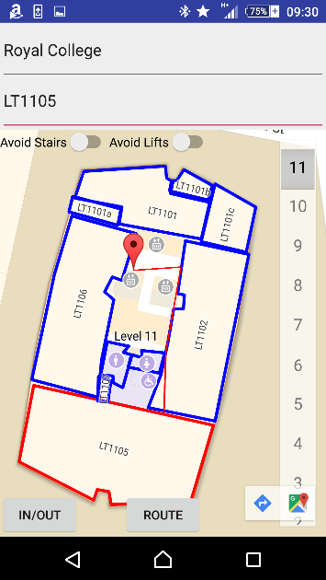

###### Figure 30 Test Ten Result One

The same route with avoid stairs enabled can be found in Figure 31.As can be seen from Figure 31 the route does now avoid stairs.

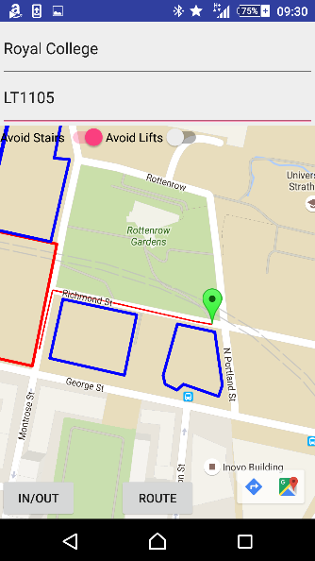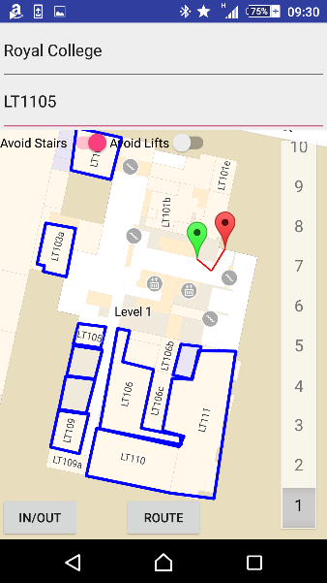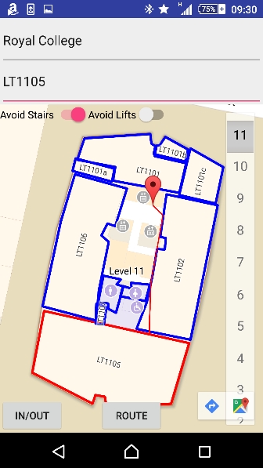

###### Figure 31 Test Ten Result Two

The same route with avoid lifts enabled can be found in Figure 32. As can be seen in Figure 32 the route does now avoid lifts.

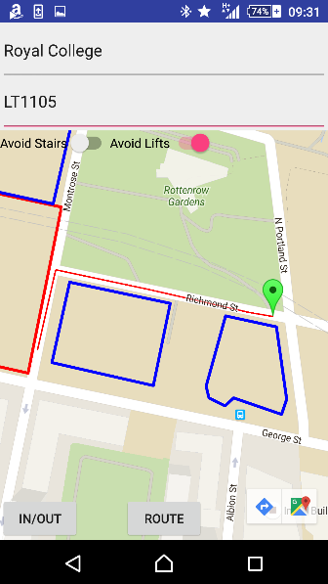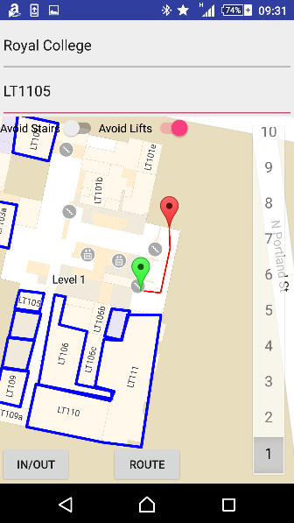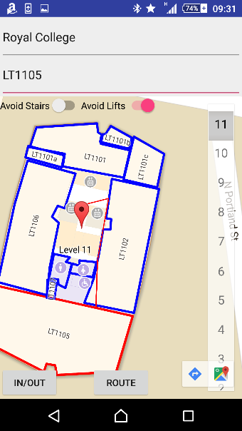

###### Figure 32 Test Ten Result Three

The same route was attempted with both avoid stairs and avoid lifts enabled. This route does not exist and the user is alerted to the fact as can be seen in Figure 33.

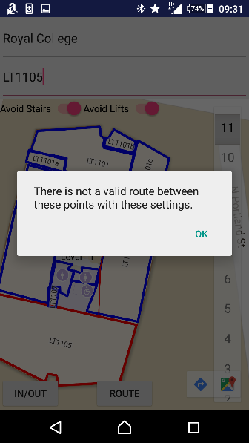

###### Figure 33 Test Ten Result Four

## Appendix 9 Installation Guide

As the application has not been released, the easiest way to install the application with the subset of data used to represent a section of the campus at Strathclyde University is to:

1. Install Android Studio from: <http://developer.android.com/sdk/index.html>
2. Download the application code from: <https://github.com/greglaw95/UniversityRoutePlanner>
3. Open the application using Android Studio
4. Connect an Android device via USB.
5. Select run inside Android Studio
6. The application should be installed and automatically open on the Android device.

## Appendix 10 User Guide

There are several actions that can be performed within the application.

### Selecting the Start or Destination

1. Tap either the top or bottom text box depending on whether you wish to select the start or destination.

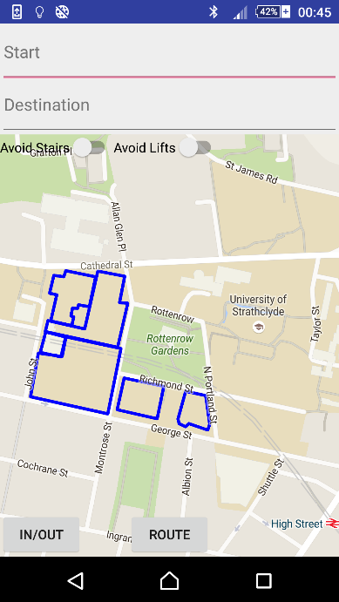

1. The start/destination can then be chosen in two ways:
   1. 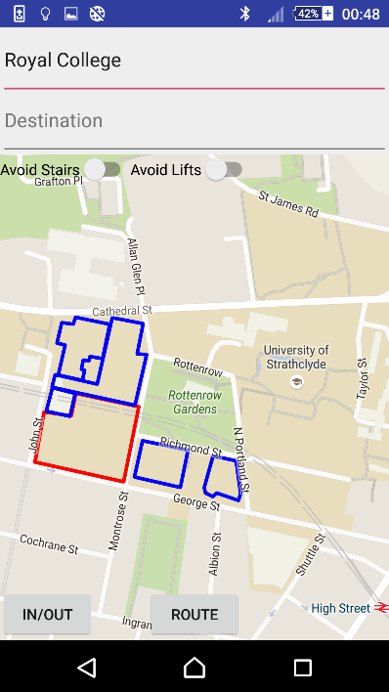Tap upon the desired location.
   2. Begin typing the name of the desired location. When the desired location appears as an option underneath the textbox tap on it.

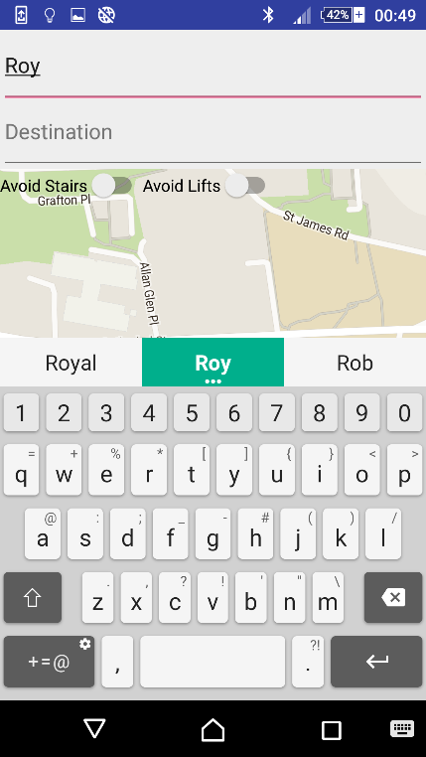

1. The location will now be displayed on screen with a red outline to indicate the selection was successful.



### Moving inside a building

1. 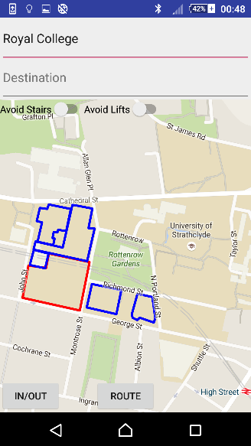Select a building as either the start or destination.
2. Press the In/Out button

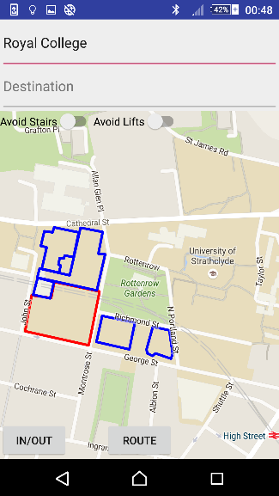

1. 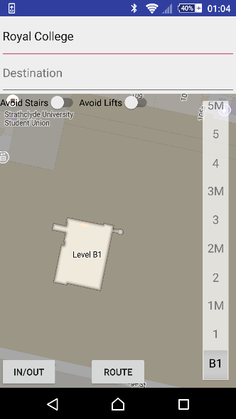The inside of that building will now be displayed.

### Changing Levels Within a Building

1. Move inside a building.



1. Using the level selector choose another floor.
2. 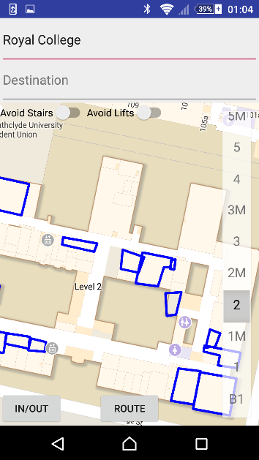The new floor will be displayed.

### Leaving a Building

1. Move inside a building.
2. Click the In/Out button.

3.The exterior of the campus will now be displayed.

### Requesting and Following a Route

1. Select a start and destination.

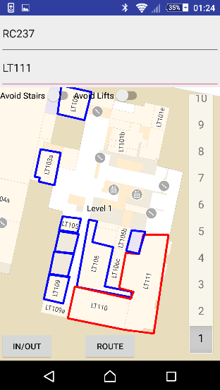

1. Click the route button.

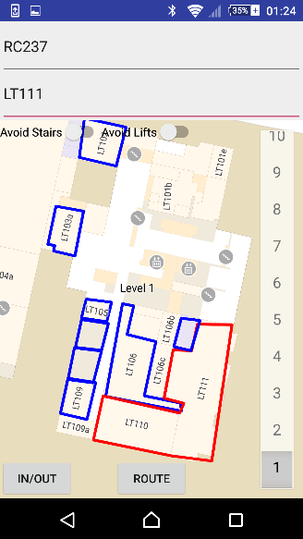

1. The beginning of the route will be displayed.

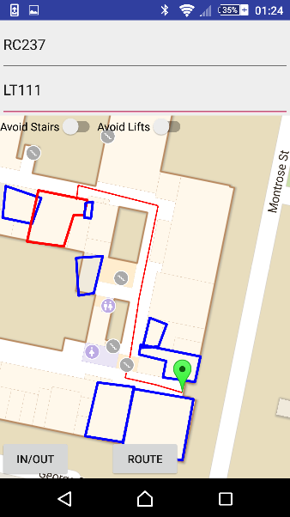

1. Click the green icon to follow the route.

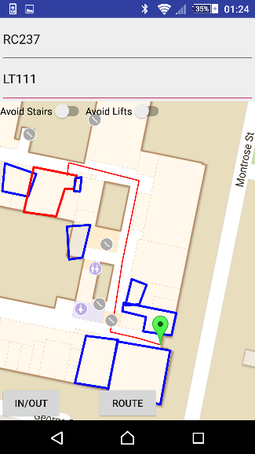

1. The next section will be displayed.

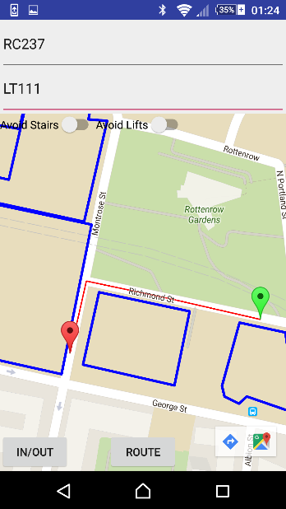

1. 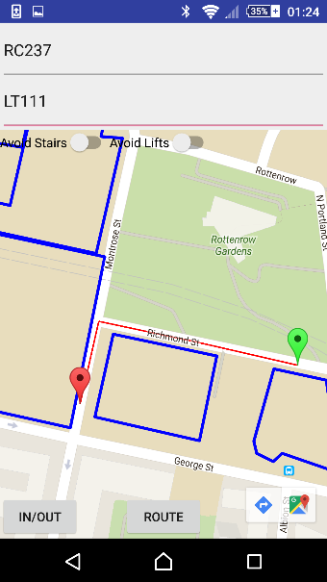Click the red icon to back track.
2. The previous section will be displayed.

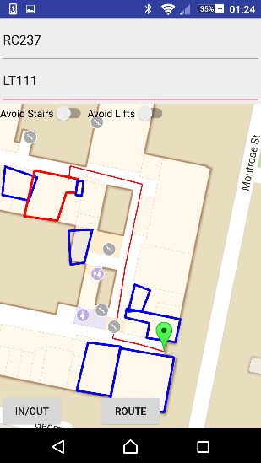

### Using Route Modifiers

1. 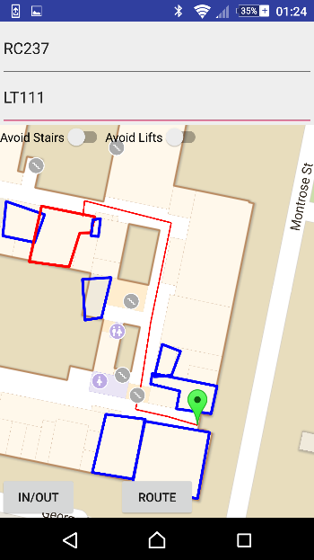Tap the switch located next to Avoid Stairs or Avoid Lifts to change the value of each modifier.
2. Using these switches select the type of route that is required.

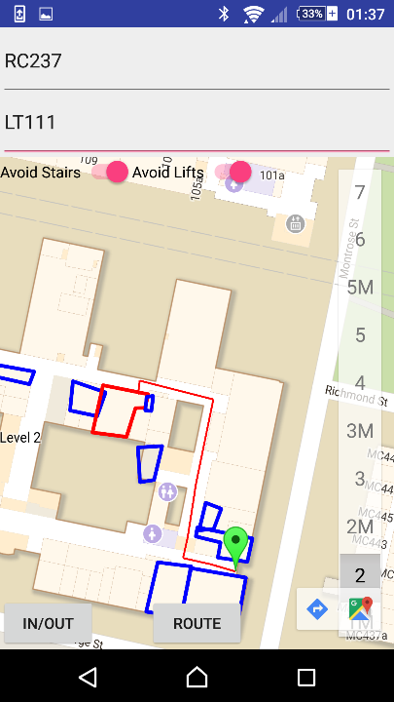

### Dismissing Error Messages

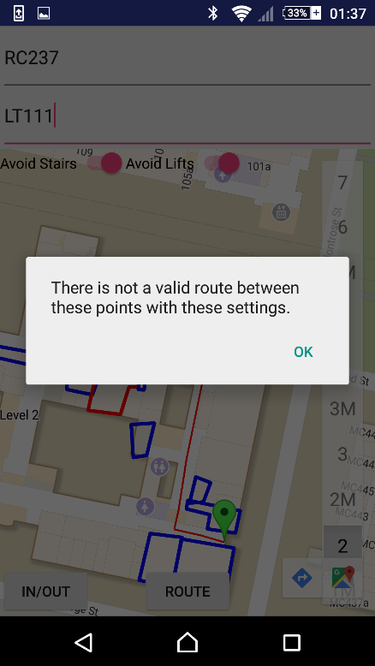1.When the error message appears click ok.

# References

|  |  |
| --- | --- |
| [1] | Trello, “Trello,” [Online]. Available: https://trello.com/b/6cUNFaP3/university-route-finder. [Accessed 25 March 2016]. |
| [2] | TomsPlanner, “Ganttify,” [Online]. Available: https://www.gantt-chart.com/. [Accessed 25 March 2016]. |
| [3] | Github, “Github,” [Online]. Available: github.com. [Accessed 25 March 2016]. |
| [4] | P. Viswanathan, “about tech,” about, 15 December 2014. [Online]. Available: http://mobiledevices.about.com/od/additionalresources/a/Native-Apps-Vs-Web-Apps-Which-Is-The-Better-Choice.htm. [Accessed 08 March 2016]. |
| [5] | International Data Corporation, “Smartphone OS Market Share, 2015 Q2,” [Online]. Available: http://www.idc.com/prodserv/smartphone-os-market-share.jsp. [Accessed 8 March 2016]. |
| [6] | Google, “Google Maps SDK for iOS,” [Online]. Available: https://developers.google.com/maps/documentation/ios-sdk/. [Accessed 8 March 2016]. |
| [7] | The Bing Maps Team, “New Bing Maps iOS SDK,” Microsoft, 5 May 2011. [Online]. Available: https://blogs.bing.com/maps/2011/05/05/new-bing-maps-ios-sdk/. [Accessed 8 March 2016]. |
| [8] | Google, “Google Maps Android API,” [Online]. Available: https://developers.google.com/maps/documentation/android-api/. [Accessed 8 March 2016]. |
| [9] | R. Brundritt, “Bing Maps Android SDK available on Codeplex,” 31 March 2011. [Online]. Available: https://blogs.bing.com/maps/2011/03/31/bing-maps-android-sdk-available-on-codeplex/. [Accessed 8 March 2016]. |
| [10] | Google, “Google Play Store,” Google, 18 March 2016. [Online]. Available: https://play.google.com/store/apps/details?id=com.google.android.apps.maps. [Accessed 25 March 2016]. |
| [11] | Smithsonian Institution, “Google Play Store: Smithsonian Mobile,” 31 January 2014. [Online]. Available: https://play.google.com/store/apps/details?id=edu.si.sim3. [Accessed 26 March 2016]. |
| [12] | radKOtev, “Google Play Store: Glasgow Uni Map,” 29 September 2014. [Online]. Available: https://play.google.com/store/apps/details?id=com.radkokotev.glasgow.uni.map. [Accessed 26 March 2016]. |
| [13] | 4 March 2016. [Online]. Available: https://www.google.co.uk/maps/dir/Glasgow/London,+UK/@53.6628863,-4.4369792,7z/data=!3m1!4b1!4m13!4m12!1m5!1m1!1s0x488815562056ceeb:0x71e683b805ef511e!2m2!1d-4.251806!2d55.864237!1m5!1m1!1s0x47d8a00baf21de75:0x52963a5addd52a99!2m2!1d-0.1277583!2d51.507350. |
| [14] | M. Rouse, “TechTarget,” September 2005. [Online]. Available: http://searchnetworking.techtarget.com/definition/GNSS. [Accessed 7 March 2016]. |
| [15] | E. K. a. C. Hegarty, “GPS Overview,” in *Understanding GPS: Principles and Applications*, Artech House, 2005, pp. 3-4. |
| [16] | GPS.gov, “GPS Accuracy,” U.S. Air Force, 18 September 2014. [Online]. Available: http://www.gps.gov/systems/gps/performance/accuracy/. [Accessed 7 March 2016]. |
| [17] | T. Bowler and M. Wall, “BBC News,” BBC, 26 August 2014. [Online]. Available: http://www.bbc.co.uk/news/business-28779524. [Accessed 7 March 2016]. |
| [18] | European Space Agency, “European Space Agency,” 18 December 2015. [Online]. Available: http://www.esa.int/Our_Activities/Navigation/The_future_-_Galileo/What_is_Galileo. [Accessed 7 March 2016]. |
| [19] | K. M. Pesyna, Jr, R. W. Heath, Jr and T. E. Humphreys, “GPS World,” 2 February 2015. [Online]. Available: http://gpsworld.com/accuracy-in-the-palm-of-your-hand/. [Accessed 7 March 2016]. |
| [20] | iPosi, “iposi.com,” 2014. [Online]. Available: http://www.iposi.com/tech-talk/the-technology. [Accessed 7 March 2016]. |
| [21] | D. Vaughan, “Geographic Location,” in *Windows Phone 7.5 Unleashed*, Sams Publishing, 2012, pp. 529-552. |
| [22] | J. Yang, A. Varshavsky, H. Liu, Y. Chen and M. Gruteser, “Accuracy Characterization of Cell Tower Localization,” UbiComp '10, New York, 2010. |
| [23] | Federal Communications Commission, “Accurate Location Detection 911 Help SMS App,” 2015. |
| [24] | Google, “Location Strategies,” [Online]. Available: http://developer.android.com/guide/topics/location/strategies.html. [Accessed 8 March 2016]. |
| [25] | S. J. Vaughan-Nichols, “ZDNet,” 16 November 2011. [Online]. Available: http://www.zdnet.com/article/how-google-and-everyone-else-gets-wi-fi-location-data/. [Accessed 9 March 2016]. |
| [26] | T. Cormen, D. Balkcom and K. A. C. C. Team, “Representing Graphs,” [Online]. Available: https://www.khanacademy.org/computing/computer-science/algorithms/graph-representation/a/representing-graphs. [Accessed 9 March 2016]. |
| [27] | TranSafety, Inc, “Study Compares Older and Younger Pedestrian Walking Speeds,” *Road Engineering Journal,* no. October, 1997, p. 1, 1997. |
| [28] | K. Wayne, “Princeton,” 2005. [Online]. Available: http://www.cs.princeton.edu/courses/archive/spr05/cos423/lectures/07maxflow-applications.pdf. [Accessed 22 March 2016]. |
| [29] | S. Fenton, “COMPILING VS TRANSPILING,” 18 November 2012. [Online]. Available: https://www.stevefenton.co.uk/2012/11/compiling-vs-transpiling/. [Accessed 23 March 2016]. |
| [30] | R. Amadeo, “How Google Inbox shares 70% of its code across Android, iOS, and the Web,” 20 November 2014. [Online]. Available: http://arstechnica.com/information-technology/2014/11/how-google-inbox-shares-70-of-its-code-across-android-ios-and-the-web/. [Accessed 23 March 2016]. |
| [31] | Safer Scotland Scottish Government, “Practical Fire Safety Guidance: The Evacuation of Disabed Persons from Buildings,” [Online]. Available: http://www.gov.scot/Resource/0040/00402451.pdf. [Accessed 22 March 2016]. |
| [32] | HM Government, “Fire Safety Risk Assesment Means of Escape for Disabled People,” [Online]. Available: https://www.gov.uk/government/uploads/system/uploads/attachment_data/file/422202/9446_Means_of_Escape_v2_.pdf. [Accessed 22 March 2016]. |
| [33] | A. De Rosa, “envatotuts+,” 8 August 2014. [Online]. Available: http://code.tutsplus.com/tutorials/html5-network-information-api--cms-21598. [Accessed 8 March 2016]. |
| [34] | w3schools, “w3schools,” [Online]. Available: http://www.w3schools.com/html/html5_geolocation.asp. [Accessed 8 March 2016]. |

# Acknowledgements

I would like to thank my project supervisor Dr David Harle, for his guidance throughout the project. I would also like to thank Colin Flynn, a Disability Advisor within the University of Strathclyde, and Derek Glenn, who organises student orders within the Electronic and Electrical Engineering Department at the University of Strathclyde, for meeting with me to discuss possible applications for the project within the university.